G197 Unit 2: Planning
  - Supplemental Information

Plan Types

- The Planning System architecture consists of three levels of planning: strategic, operational, and tactical.
- Strategic-level planning sets the context and expectations for operational planning. It focuses on longer-term planning activities that help unify stakeholder efforts that support a comprehensive and effective approach to solving a given objective.
  - Example: The National Cohesive Wildland Fire Management Strategy that outlines new approaches to coordinate and integrate efforts to prepare communities for fire season and better address the Nation’s wildland fire threats.

- Operational-level planning provides the tasks and resources needed to execute the strategy. It is influenced by the objectives (end goals) and priorities that were identified by strategic level planning and an understanding of specific organizational or jurisdictional risks.

  - Example: Emergency Operations Plans that manage a wide variety of potential threats and hazards. These plans detail who is responsible for carrying out specific actions; identify personnel, equipment, facilities, supplies, and other resources available; and outline how actions will be coordinated.

- Tactical-level planning shows how to apply resources to complete the operational tasks within a given time frame. They focus on managing resources such as personnel and equipment that play a direct role in an incident or event.

  - Example: Incident Action Plans that contain real-time information that provide overall priorities, objectives, strategies, and tactics for the management of an incident

Potential Planning Team/Committee Members

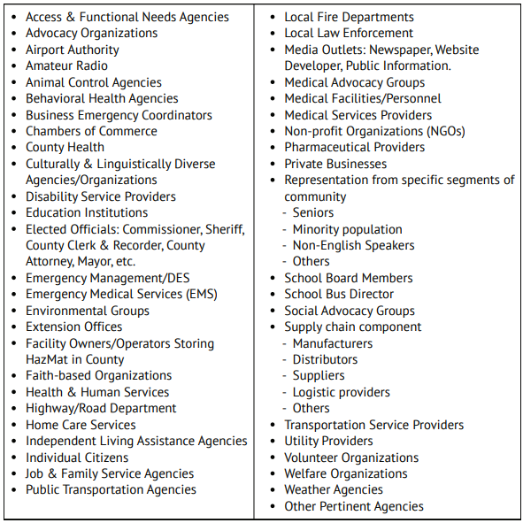

CPG 101 - Incorporating Individuals with Access and Functional Needs

- Does the planning group include individuals with disabilities and others with access and functional needs, as well as relevant advocacy groups, service providers, and subject matter experts?
- Does the plan include a definition for “individuals with disabilities and others with access and functional needs,” consistent with all applicable laws?
- Does the plan include demographic data and information on the number of individuals in the community with disabilities and others with access and functional needs (using assessment and current registry data, if available)?
- Does the plan identify the agency with the lead role for coordinating planning efforts and ensuring that individuals with access and functional needs are incorporated into all plans?
- Does the plan identify support agencies to assist the lead agency in coordinating planning efforts and ensuring individuals with access and functional needs are incorporated into all plans?
- Does the plan identify a disability advisor to provide expertise for the emergency planning process and to support the Incident Commander, the Planning Section, and/or the Operations Section during an emergency?
- Does the plan include mechanisms or processes to effectively identify people who will need additional assistance and their specific health-related needs in advance of, during, and following an emergency?
- Does the plan include mechanisms or processes to secure medical records to enable persons with disabilities or access and functional needs and acute health care needs to receive health care and sustained rehabilitation in advance of, during, and following an emergency?
- Does the plan identify which position/agency is authorized to direct supporting departments and agencies to furnish materials and commodities for individuals with disabilities and others with access and functional needs?
- Does the plan identify critical human services and ways to reestablish these services following a disaster for individuals with disabilities and others with access and functional needs to enable individuals to regain and maintain their previous level of independence and functioning?
- Does the plan identify roles and responsibilities for supporting individuals with disabilities and others with access and functional needs during both the short- and long-term recovery process?
- Does the plan prioritize governmental, nongovernmental, and private sector resources to meet critical needs such as accessible housing, rental assistance, debris removal, and emergency repairs for individuals with disabilities and others with access and functional needs?
- Does the plan include mechanisms or processes for the training and use of spontaneous volunteers to assist with physical, programmatic, and communications access and other functional needs?

CMIST Planning Tool

Communication:

During an emergency, people with communication needs may not be able to hear announcements, see signs, understand messages or verbalize their concerns. These are people who have limited or no ability to speak, see, hear or understand.

Planning Considerations

Note: A central theme of Whole Community planning is building relationships within the community and ensuring that support also comes from the community. Reaching people through trusted channels has shown to be much more effective than through mainstream channels. For some people, trusted information comes more readily from within their communities than from external sources.

ð | Does your plan include outreach to local community networks that support at-risk individuals (such as those you may have used to assist in identifying who is at-risk)?
ð | Does your plan include communication paths that reach individuals who have limited English proficiency, are deaf or hard of hearing, and are blind or have low vision? These communication channels should be used before, during, and after an emergency.
ð | Does your plan include multiple delivery channels for emergency/alert messaging (such as television, radio, social media, internet pages, texting, reverse 911, ethnic media, HAM radio networks, etc.)?

Resource/Partner Considerations

- Accessible documents also in languages of the local community
- Assistive Technology Partners
- Braille Partners
- CART (Communication Access Realtime Translation)
- Local Colleges
- Large print
- Loop Systems
- Microphones
- Multi Language interpreters
- Pictures to communicate
- Pocket Talkers
- Relay Services
- Ubi Duo (a 2-way resource for communicating with people who are deaf)

Maintaining Health:

People may require assistance in managing activities of daily living such as eating, dressing, grooming, transferring and going to the toilet. It includes managing chronic, terminal or contagious health conditions (such as ongoing treatment and administration of medications, IV therapy, catheters, tube feeding, dialysis, oxygen, operating life sustaining equipment...). Early identification of these needs and intervention can avoid decline of health.

Planning Considerations

ð | Does your plan include consideration for those who need assistance in maintaining activities of daily living (such as toileting, eating, or dressing)?
ð | Depending on the type of plan, do you have appropriate supplies (or a plan for obtaining them) that support daily living to assist individuals who might not have been able to bring supplies with them (such as extra feeding tubes, diapers, formula, bandages, etc.)?
ð | Does your plan include resources to find the availability of open pharmacies so that individuals can use them to obtain daily medication, if applicable?
ð | Does your plan encourage individuals receiving recurring medical services to prepare with their care team (such as dialysis or medication assisted treatment, or other ongoing treatment for behavior health and/or substance use disorder)?
ð | Does your plan include considerations for medical conditions individuals of any age may have (such as infants or older adults)? For example, do you have common durable medical equipment that could support your at-risk population?

Resource/Partner Considerations

- Adaptive Equipment Partners
- Back Up Power Partners
- Dialysis Center Partners
- Donation Management Partners
- Durable Medical Equipment Partners
- Grocery Stores Partners
- Home Health Partners
- Medical Reserve Corp (MRC)
- Oxygen Supplier Partners
- Pharmacy Partners
- Trach Supply Partners
- VOAD partners

Independence:

People who are able to function independently by having their assistive devices and/or equipment. Items consist of mobility aids (such as wheelchairs, walkers, canes, crutches), communication aids, medical equipment (such as catheters, oxygen, syringes, medications), and service animals. Individuals may become separated from their assistive equipment and/or animals in an emergency. Those at risk whose needs are recognized and restored early are able to maintain their independence and manage in mass shelters. Effectively meeting their functional needs prevents secondary complications.

Planning Considerations

ð | Does your plan appropriately support individuals who use mobility devices or assistive technology in daily living (such as wheelchairs or walkers, vision and communication aids, etc.)?
ð | Does your plan take into account support or access for service animals (such as clarifying for volunteers/staff the definition of a service animal, and the difference between a service and an assistance animal)?

Resource/Partner Considerations

- Adaptive Equipment Partner
- Assistive Equipment Partner
- Backup Power Partner
- Bariatric Cot Partner
- Battery Partner
  - Cell phone recharging Station
  - Communication Aid
  - Hearing Aid
  - Power Wheelchair Battery
- Centers for Independent Living
- Donation Management Partner
- Durable Medical Equipment Partner for access to:
  - Canes
  - Canes
  - Crutches
  - Wheelchairs
- Housing Partners:
  - Accessible
  - Homeless
  - Low-income
- Oxygen Supplier Partner
- Service Animal Partner
- Volunteer Management Partner

Service and Support:

Some people may require Safety/Supports/Services include those who have psychiatric conditions (such as dementia, Alzheimer, Schizophrenia, depression or severe mental illness), addiction problems, brain injury or become anxious due to transfer trauma. During an emergency, some people with mental illness may be able to function well while others require a more protected and supervised setting.

Planning Considerations

ð | Does your plan include providing behavioral health support for those who are affected by an emergency? This could include supporting existing needs, such as a diagnosed condition, or new needs as a result of an emergency.
ð | Does your plan include information on where or how individuals can receive behavioral health support?
ð | Does your plan include processes to support the needs of pregnant women, nursing mothers and infants, or children (such as a location to care for infants/children, or a location to pump/nurse, etc.)?

Resource/Partner Considerations

- Alzheimer Association Partner
- Bank Partners
- Behavioral Health Partner
- Brain Injury Partner
- Chamber of Commerce Partner
- Clothing Bank Partner
- Dept of Human Service
- Food Bank Partner
- Homeless Service Partner
- Housing Organization Association
- Insurance Partners
- Local Community Center Board Partner
- Medical Reserve Corp MRC
- Public Health Partner
- Public School Partners
- Tourist Service Partners
- UPS and FedEx partners

Transportation:

Emergency response requires mobility and this category includes people who are unable to drive because of disability, age, temporary injury, poverty, addiction, legal restriction or have no access to a vehicle. Wheelchair accessible transportation may be necessary. Pre-planning evacuation needs help prevent chaos during an emergency and many people can function independently once they are evacuated to safety.

Planning Considerations

ð | Does your plan incorporate mass transit needs or considerations?
ð | Does your plan outline contracts or have a memorandum of understanding in place of transportation resources in the event of an emergency?
ð | Does your plan include alternate transportation resources should primary resources be affected or unavailable due to the emergency?

Resource/Partner Considerations

- Adult Day Programs
- Ambulance Services
- Area Agencies on Aging
- Assistive Living and Skilled Nursing Care
- Local Jail/Prison Partners
- Local Schools
- Medical Appointment Transportation Partners
- Paratransit Providers
- Paratransit Vehicle Dealers
- Public Transportation Partners
- Rental Car Partners

