Off-Campus Online Application Job Aid
The National Fire Academy and the Emergency Management Institute have transitioned to an online admissions system. The online admissions application can be found (you may need to depress CTRL to access the link):
General Admissions Application (https://training.fema.gov/generaladmissionsapplication/staticforms/startapplication.aspx)
If a student has an issue or a question regarding the online admissions system or the process, please contact:
NETC Admissions Department
(301) 447-1035
NETCAdmissions@fema.dhs.gov

The online application will open the day before the class and remain open for 14 days after the class ends. A failure to turn in an application will result in not receiving credit for the course.
Tutorial:

NOTE: Information is required for each of the starred fields.

Step 1: After reading the Legal Notice, click continue.

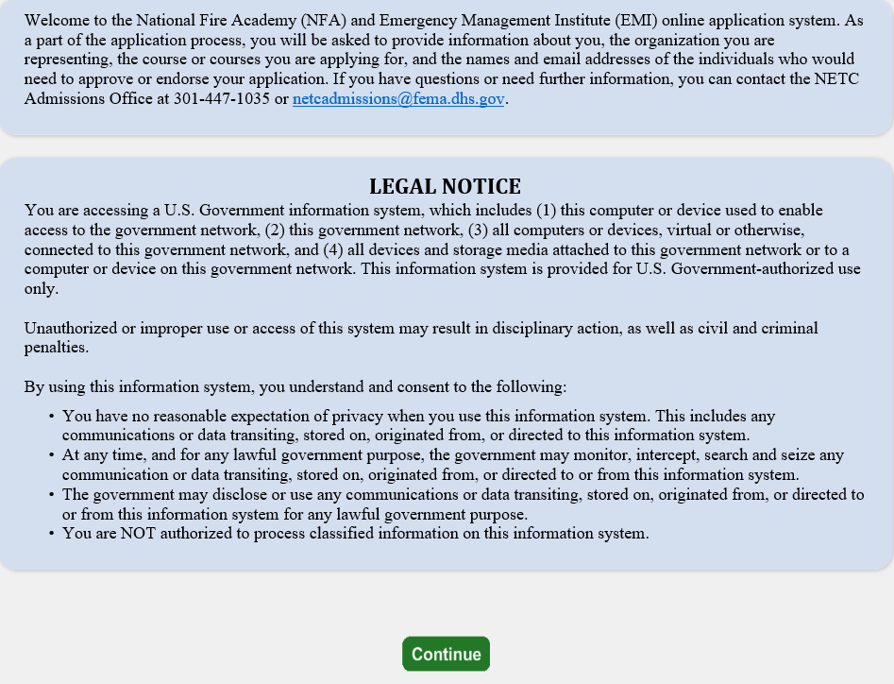

Step 2: Read the statements below and click continue if you have a FEMA Student Identification (SID) Number. If not, follow the instruction for obtaining one.

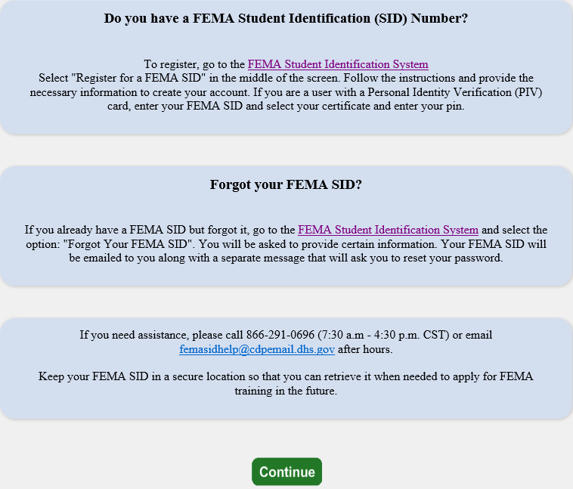

Step 3: Read the statements below, check the box at the bottom, and click continue.

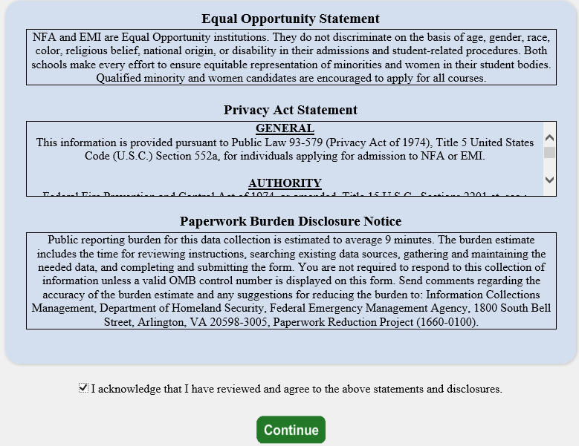

Step 4: The student must input their ten-digit FEMA Student ID and first and last names. If you do not already have a FEMA Student ID (SID), go to FEMA Student Identification System (https://cdp.dhs.gov/femasid) to register for one. The student must click “Verify” after entering their FEMA SID and first and last names. The system will return the middle name, suffix, and date of birth from the SID system.
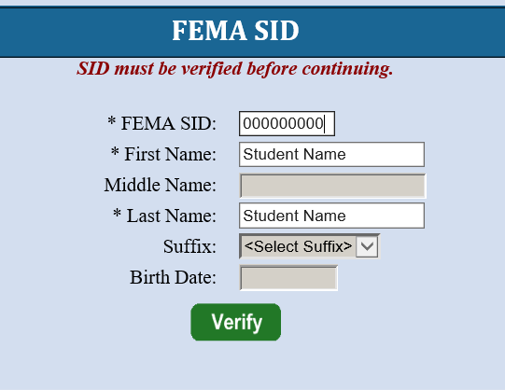
Step 5: To continue, the student must see “Verified!” after clicking Verify. Select next to continue.
Step 6: Complete the fields on the Demographic Information screen (starred fields are required). Select next to continue.
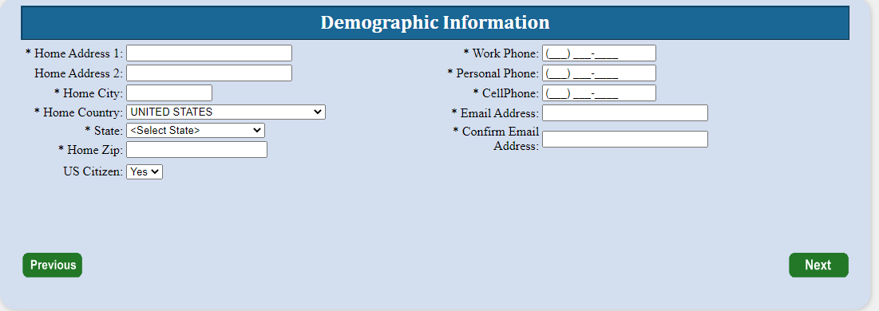
Step 7: The Course/Offer Information screen requires the student to select a course. To do this the student must select the drop-down arrow and scroll to the applicable course code. Some offerings are restricted to certain groups. If that is the case, the course sponsor will provide an Invitation Code which must be entered for the offering to appear on the drop-down list. Select apply and then select next. The invitation code is HTWIN. Click on apply after entering the code, then select the course from the drop down, then click apply.
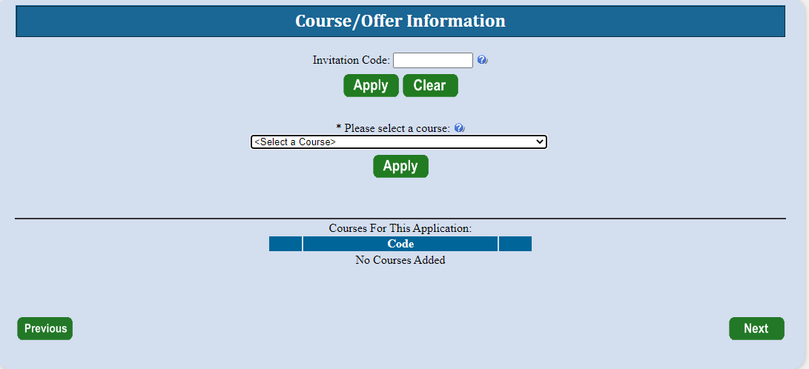

Step 8: The Course/Offer Information (continued) screen allows the student to select the Offer Start Date and Offer Location from the drop-down. There is no need to select an Offer Title. In the “Briefly describe…” box, enter the requested information. If you have a disability or require a special accommodation, please select Yes from the drop-down. Once completed, select save then next.
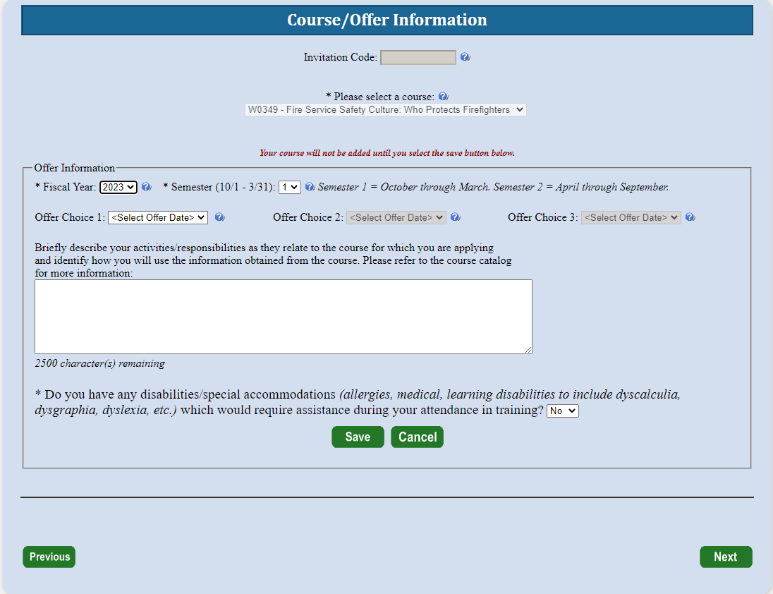

Step 9: On the Organizational Information section, the student must fill in all information requested including a box in each category. Once completed the student should select next.
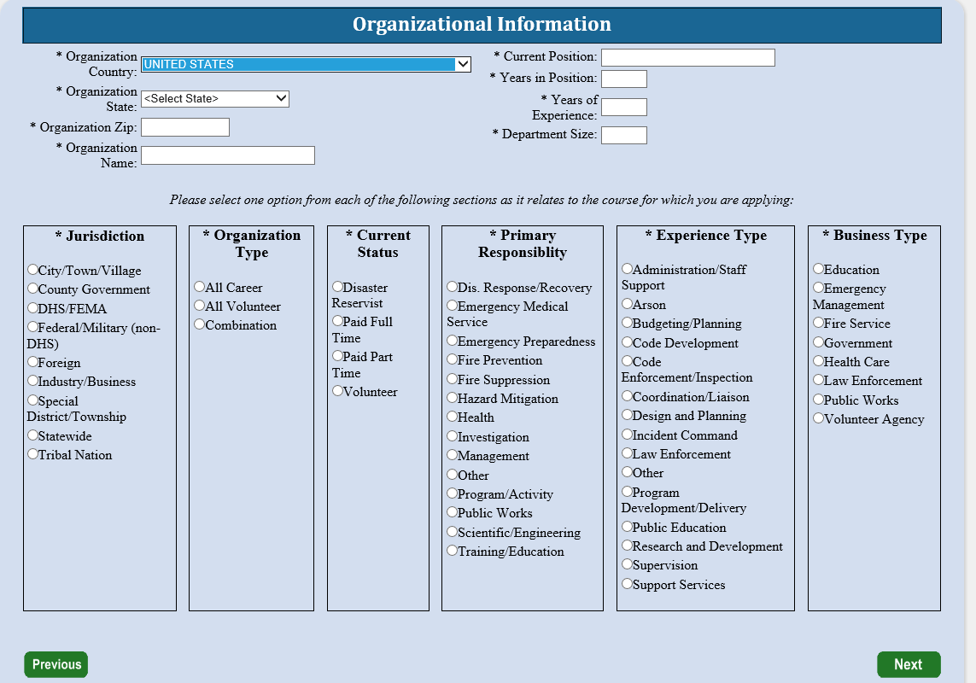
Step 10: The next screen is labeled Other Information. This section is optional. These fields are used for statistical purposes only. Once completed select next.
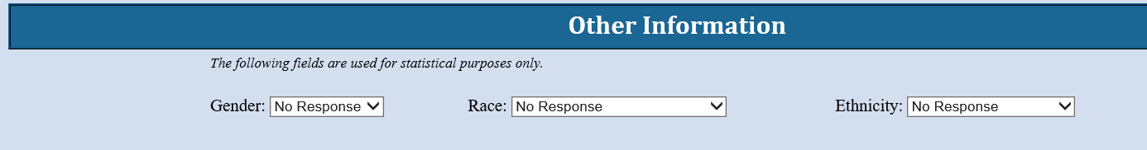

Step 11: If there are no attachments, select continue. Click browse to attach any prerequisite certification of completion, then click attach and ensure the files show up under Attached Files. IS393.b is required, and your application won’t be accepted if you do not attach the certification.
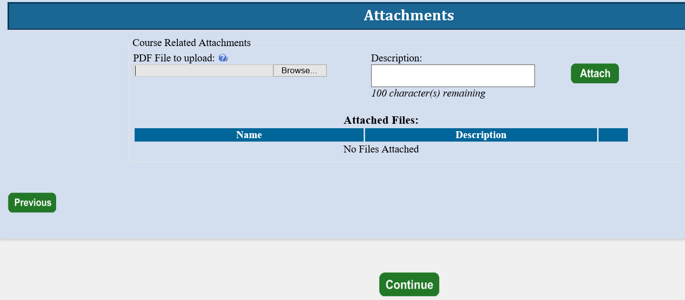
Step 12: At this point, the student will see a screen where they will be asked if they have completed all the information. They should select Yes. If there is any required information that is missing, they will need to go back and correct that before the application is forwarded.
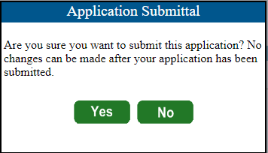

Step 13: The Head of Organizational Information is where the student enters the name and email address of the person who has been designated to endorse the application. Once the student clicks submit, the Head of the Sponsoring Organization has 14 days to respond to the request or it will be automatically rejected.
For this training, you can use Joan Huston as Head of Organization. Email is joan.huston@fema.dhs.gov.
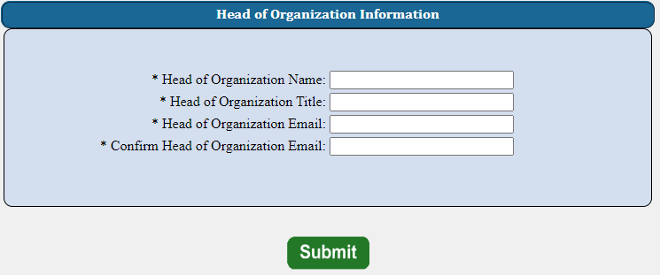
Step 14: This is the final screen showing the student that they successfully applied for their selected course.
