1 Introduction 1-1
1.1 Executive Summary 1-1
1.2 Purpose 1-2
1.3 Background and Scope 1-3
1.4 Plan Organization 1-3
1.5 Multi-Jurisdictional Planning 1-4
2 Region Profile 2-1
2.1 Geography and Climate 2-1
2.2 Population 2-3
2.3 Development Trends 2-4
2.4 Economy 2-5
2.5 Capability Assessment 2-7
3 Planning Process 3-1
3.1 Background on Mitigation Planning in Western Montana 3-1
3.2 Government Participation 3-3
3.3 The 10-Step Planning Process 3-3
3.4 Tribal Mitigation Planning Process 3-11
3.5 EPA Regional Resilience Toolkit 3-12
4 Hazard Analysis and Risk Assessment PLACEHOLDER 4-1
5 Mitigation Strategy 5-1
5.1 Mitigation Strategy: Overview 5-1
5.2 Mitigation Goals 5-1
5.3 Identification and Analysis of Mitigation Actions 5-2
5.4 Mitigation Action Plan 5-4
6 Plan Adoption, Implementation, and Maintenance 6-1
6.1 Formal Adoption 6-1
6.2 Implementation 6-1
6.3 Plan Maintenance 6-2

Jurisdictional Annexes
- Carbon County
- Crow Tribe
- Custer County
- Daniels County
- Garfield County
- Powder River County
- Prairie County
- Roosevelt County
- Sheridan County
- Valley County
- Yellowstone County

Jurisdictional Addendums
- Big Horn County
- Carter County
- Dawson County
- Fallon County
- Golden Valley County
- McCone County
- Musselshell County
- Richland County
- Rosebud County
- Stillwater County
- Treasure County
- Wheatland County

Appendices:
- Appendix A Hazard Mitigation Planning Committees
- Appendix B Planning Process Documentation
- Appendix C Public Input
- Appendix D Adoption Resolutions and Plan Approval
- Appendix E References

Introduction

Executive Summary
The Eastern Montana Region Hazard Mitigation Plan (HMP) is the product of a regional planning process coordinated by Montana Disaster & Emergency Services (MT DES) in 2022-2023 to develop regional hazard mitigation plans covering the entire State of Montana. The following jurisdictions have prepared and adopted this Plan:
- Big Horn County
  - City of Hardin
  - Town of Lodge Grass
- Carbon County
  - Town of Bearcreek
  - Town of Bridger
  - Town of Fromberg
  - Town of Joliet
  - Town of Red Lodge
- Carter County
  - Town of Ekalaka
- Crow Tribe
- Custer County
  - City of Miles City
  - Town of Ismay
- Daniels County
  - City of Scobey
  - Town of Flaxville
- Dawson County
  - City of Glendive
  - Town of Richey
- Fallon County
  - City of Baker
  - Town of Plevna
- Garfield County
  - Town of Jordan
- Golden Valley County
  - Town of Ryegate
  - Town of Lavina
- McCone County
  - Town of Circle
- Musselshell County
  - Town of Melstone
  - Town of Roundup
- Powder River County
  - Town of Broadus
- Prairie County
  - Town of Terry
- Richland County
  - Town of Fairview
  - Town of Sidney
- Roosevelt County
  - City of Wolf Point
  - City of Poplar
  - Town of Bainville
  - Town of Culberson
  - Town of Froid
- Rosebud County
  - City of Colstrip
  - City of Forsyth
- Sheridan County
  - City of Plentywood
  - Town of Medicine Lake
  - Town of Outlook
  - Town of Westby
- Stillwater County
  - Town of Columbus
- Treasure County
  - Town of Hysham
- Valley County
  - City of Glasgow
  - Town of Fort Peck
  - Town of Nashua
  - Town of Opheim
- Wibaux County
  - Town of Wibaux
- Yellowstone County
  - City of Billings
  - Town of Broadview
  - Town of Laurel

The purpose of hazard mitigation is to reduce or eliminate long-term risk to people and property from disasters or hazard events. The impacts of hazards can often be lessened or even avoided if appropriate actions are taken before events occur. Studies have found that hazard mitigation is extremely cost-effective, with every dollar spent on mitigation saving an average of $6 in avoided future losses. By reducing exposure to known hazard risks, communities will save lives and property and minimize the social, economic, and environmental disruptions that commonly follow hazard events.
The 2023 Eastern Montana Region HMP (also referred to as “Plan”) will serve as a blueprint for coordinating and implementing hazard mitigation policies, programs, and projects across the Region. It identifies mitigation goals and related actions to assist the participating jurisdictions in reducing risk and preventing loss from future hazard events. The goals of the 2023 Eastern Montana Region HMP are:
Goal 1: Reduce impacts to people, property, the environment, and the economy from hazards by implementing whole-community risk reduction and resilience strategies.
Goal 2: Protect community lifelines and critical infrastructure to ensure the continuity of essential services during and after a disaster.
Goal 3: Support education and outreach to the public through improved communications and capacity building that enhances resilience among underserved communities.
Goal 4: Promote regional cooperation and leverage partnerships with the private sector, non-profit organizations, and other key stakeholder groups in mitigation solutions.
Goal 5: Sustain and enhance jurisdictional capabilities and resources to enact and implement mitigation activities.
Goal 6: Integrate hazard mitigation into other plans, processes, and regulations.
Goal 7: Ensure local mitigation programs address underrepresented groups and protect socially vulnerable populations.
Goal 8: Incorporate the potential impacts of climate change into all mitigation activities.
These goals were tailored for the Eastern Region during group exercises at a series of mitigation strategy workshops. This Plan was also developed to maintain the participating jurisdictions’ eligibility for federal disaster assistance, specifically the Federal Emergency Management Agency’s (FEMA) Hazard Mitigation Assistance (HMA) grants including the Hazard Mitigation Grant Program (HMGP), Flood Mitigation Assistance (FMA) program, and Building Resilient Infrastructure and Communities (BRIC) grant program, as well as the Rehabilitation of High Hazard Potential Dam (HHPD) grant program.
It is important that local decision-makers stay involved in mitigation planning to provide new ideas and insight for future updates to the Regional HMP. As a long-term goal, the Regional HMP and the mitigation strategies identified within will be fully integrated into the daily decisions and routines of local government. This will continue to require dedication and hard work, and to this end, this Plan update continues efforts to further strengthen the resiliency of the Eastern Region.

Purpose
The participating jurisdictions of the Eastern Montana Region prepared this Regional HMP to guide hazard mitigation planning and to better protect the people and property of the planning area from the effects of hazard events. This Plan demonstrates the Region’s commitment to reducing risks from hazards and serves as a tool to help decision-makers direct mitigation activities and resources. This Plan also maintains the jurisdictions’ eligibility for federal mitigation grants under FEMA’s HMA grant programs. This Plan demonstrates the Region and participating jurisdictions’ commitment to reducing risks from hazards and serves as a tool to help decision-makers direct mitigation activities and resources.

Background and Scope
Each year in the United States, disasters take the lives of hundreds of people and injure thousands more. Nationwide, taxpayers pay billions of dollars annually to help communities, organizations, businesses, and individuals recover from disasters. These monies only partially reflect the true cost of disasters because additional expenses to insurance companies and nongovernmental organizations (NGOs) are not reimbursed by tax dollars. Many disasters are predictable, and much of the damage caused by these events can be alleviated or even eliminated.
Hazard mitigation is defined by FEMA as “any sustained action taken to reduce or eliminate long-term risk to human life and property from a hazard event.” The results of a three-year, congressionally mandated independent study to assess future savings from mitigation activities provides evidence that mitigation activities are highly cost-effective. On average, each dollar spent on mitigation saves society an average of $6 in avoided future losses in addition to saving lives and preventing injuries (Natural Hazard Mitigation Saves, 2019 Report).
Hazard mitigation planning is the process through which hazards that threaten communities are identified, likely impacts of those hazards are determined, mitigation goals are set, and appropriate strategies to lessen impacts are developed, prioritized, and implemented. This Plan documents the planning region’s hazard mitigation planning process, identifies relevant hazards and risks, and identifies the strategies that each participating jurisdiction will use to decrease vulnerability and increase resiliency and sustainability.
This Plan was prepared pursuant to the requirements of the Disaster Mitigation Act of 2000 (Public Law 106-390) and the implementing regulations set forth by the Interim Final Rule published in the Federal Register on February 26, 2002 (44 Code of Federal Regulations [CFR] §201.6) and finalized on October 31, 2007 (hereafter, these requirements and regulations will be referred to collectively as the Disaster Mitigation Act (DMA)). While the DMA emphasized the need for mitigation plans and more coordinated mitigation planning and implementation efforts, the regulations established the requirements that local hazard mitigation plans must meet for a local jurisdiction to be eligible for certain federal disaster assistance and hazard mitigation funding under the Robert T. Stafford Disaster Relief and Emergency Act (Public Law 93-288). Because the Eastern Region planning area is subject to many kinds of hazards, access to these programs is vital.
Information in this Plan will be used to help guide and coordinate mitigation activities and decisions for local land use policy in the future. Proactive mitigation planning will help reduce the cost of disaster response and recovery to communities and property owners by protecting critical community facilities, reducing liability exposure, and minimizing overall community impacts and disruption. The jurisdictions in the Eastern Region planning area have been affected by hazards in the past and are thus committed to reducing future disaster impacts and maintaining eligibility for federal funding.

Plan Organization
The Eastern Montana Region HMP is organized in alignment with the DMA planning requirements and the FEMA plan review tool as follows:
- Chapter 1: Introduction
- Chapter 2: Region Profile
- Chapter 3: Planning Process
- Chapter 3.4: Hazard Analysis and Risk Assessment
- Chapter 5: Mitigation Strategy
- Chapter 6: Plan Adoption, Implementation, and Maintenance
- County and Tribal Annexes and Addendums
- Appendices
Each annex provides a more detailed assessment of each jurisdiction’s unique risks as well as their mitigation strategy to reduce long-term losses. Each annex contains the following:
- Mitigation Planning and County Planning Team
- Community Profile
- Hazard Identification and Risk Assessment
- Vulnerability to Specific Hazards
- Mitigation Capabilities Assessment
- Mitigation Strategy
- Plan Implementation and Maintenance
When this Plan was organized and initiated in 2022 several counties in the Region had recently approved HMPs. It was determined by MT DES and FEMA Region VIII to only require implementation updates associated with the mitigation strategy in an Addendum that aligned with the counties existing HMP and current FEMA policy guidance, rather than conducting new analysis in an Annex. Each addendum discusses the following topics, as each relates to plan implementation and maintenance:
- Mitigation Planning
- Summary Overview of the jurisdiction’s recently-approved HMP’s progress
- Social Vulnerability
- Hazard Events within the Planning Area (natural hazard events that have occurred since the jurisdiction’s HMP was recently approved)
- Changes in Risk Exposure in the Planning Area
- Mitigation Capabilities Assessment
- Review of the Mitigation Action Plan

Multi-Jurisdictional Planning
This Plan was prepared as a regional, multi-jurisdictional plan. The Eastern Montana Region is comprised of 22 counties and one tribal reservation, as established by MT DES. All tribes, counties, and incorporated municipalities in the Region were invited to participate in the planning process. The Fort Peck Tribes, as known as Fort Peck Assiniboine and Sioux Tribes; Northern Cheyenne Tribe; and Wheatland County elected not to participate in the Regional plan. Wheatland County and Northern Cheyenne Tribe elected not to participate due to limited staff and resources; the Fort Peck Tribes did not participate because they were already developing a full HMP update. All other tribes, counties, and incorporated municipalities fully participated in the planning process, and have committed to adopt and implement the Regional HMP. The participating jurisdictions seeking FEMA approval of this plan are listed in Section 1.1.

Region Profile
This section provides a brief overview of the geography of the planning area. A base map of the planning region is illustrated in Error! Reference source not found. below.

Geography and Climate
The Eastern Montana Region is comprised of the following 22 counties and one tribal reservation that participated in the Regional HMP planning process:

- Big Horn County
- Carbon County
- Carter County
- Crow Tribe
- Custer County
- Daniels County
- Dawson County
- Fallon County
- Garfield County
- Golden Valley County
- McCone County
- Musselshell County
- Powder River County
- Prairie County
- Richland County
- Roosevelt County
- Rosebud County
- Sheridan County
- Stillwater County
- Treasure County
- Valley County
- Wibaux County
- Yellowstone County

The Eastern Region is dominated by prairie landscape as part of the Great Plains. Some parts of eastern Montana, in areas most prone to drying chinooks, have near-desert conditions and scrub rather than grassland. Eastern Montana also has breaks and highlands that are widely forested, such as the Custer National Forest and areas around Fort Peck Lake. Eastern Montana has a semi-arid steppe climate with low precipitation that is to some extent countered by low evaporation rates. According to Western Regional Climate Center (WRCC), probably the driest part of Montana is along the Clark Fork of the Yellowstone River in Carbon County. In this area, eight miles south-southwest of Belfry, the average precipitation for a 16-year period is 6.59 inches. In the Eastern Region, summers are short but hot and winters are long, cold and extremely variable. The major rivers that flow through the Eastern Region include Missouri River, Yellowstone River, Milk River, and Tongue River. The Missouri River, the longest river in the United States and Yellowstone County, the most populous county in Montana, are both included in the Eastern Region. The National Oceanic and Atmospheric Administration (NOAA) National Centers for Environmental Information also noted that tornadoes occur almost entirely in the Eastern Region. Blizzards are also most common in the northeastern part of the State, occurring about five times per year. The eastern part of the State can also experience bitterly cold temperatures, occasionally lower than −30°F.
Major roadways include Interstate 94, Interstate 90, Highway 2, Highway 12, Highway 121, and Highway 87. Figure 2-2 below shows the land ownership within Eastern Montana.
As mentioned previously, the Eastern Region receives lower annual precipitation compared to the western part of the State. Precipitation is typically higher in the southeastern portion of the region compared to the northwestern portion. The Eastern Region also experiences distinct seasons. Spring and fall tend to be relatively short transitional periods, with mild temperatures. The Eastern Region can also experience rapid weather changes, with significant temperature swings during these seasons. Winters in the Eastern Region are cold, with average temperatures ranging from the mid-20s°F to the low 30s°F. Temperatures can drop well below freezing, and snowfall is common. Blizzards and strong winds can occur during the winter months, creating hazardous travel conditions. Summers are generally hot and dry, with average high temperatures ranging from the upper 80s°F to the mid-90s°F. Heatwaves are not uncommon, and temperatures can occasionally exceed 100°F during the hottest months of July and August. Additional geography and climate data for each jurisdiction within the Eastern Region can be found in the Community Profile section of each jurisdictional annex and addendum.

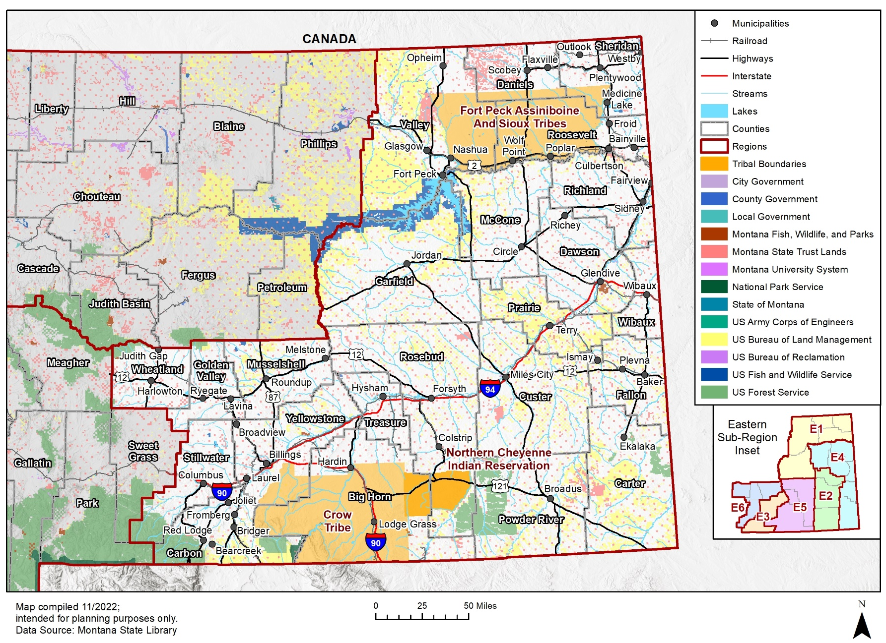
Figure 2-1 Eastern Montana Region Base Map

Figure 2-2 Federal Lands and Indian Reservations Montana
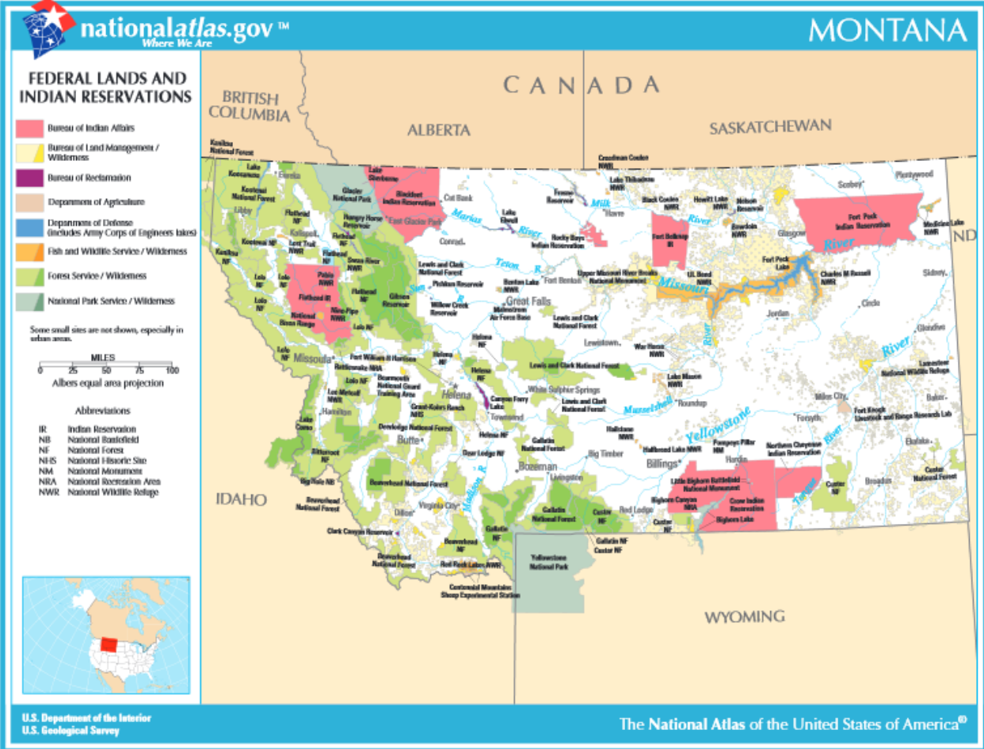

Population
Table 2-1 summarizes the estimated population and population change for the Eastern Region planning area as a whole and for the individual counties. Data is based on the American Community Survey (ACS) data from the US Census Bureau. Most of the counties in Eastern Montana, besides Garfield, Rosebud, and Treasure counties, have experienced significant or mild population growth over the past decade. The entire Eastern Region’s population increased almost 10% in the past decade. The Eastern Region was home to 25.3% of Montana’s total population of 1,104,271 in 2021. Please note that Wheatland County’s population was not included in Table 2-1 since the County elected not to participate in the regional planning process. Overall, the Eastern Region is growing rapidly in population, but the percent change varies by county within the Eastern Region.
Table 2-1 Eastern Region Population Change
County | 2010 Census | 2016  Estimate | 2017  Estimate | 2018  Estimate | 2019  Estimate | 2020  Census | 2021 Estimate | % Change 2010 to 2021
Big Horn County | 12,663 | 13,214 | 13,290 | 13,376 | 13,387 | 13,302 | 13,198 | 4.22%
Carbon County | 9,994 | 10,340 | 10,466 | 10,546 | 10,597 | 10,689 | 10,488 | 4.94%
Carter County | 1,289 | 1,295 | 1,320 | 1,318 | 1,331 | 1,305 | 1,349 | 4.65%
Custer County | 1,649 | 1,787 | 1,788 | 1,753 | 1,730 | 1,705 | 1,739 | 5.45%
Daniels County | 8,933 | 9,431 | 9,324 | 9,191 | 9,017 | 8,824 | 9,003 | 0.78%
Dawson County | 2,813 | 2,913 | 2,925 | 2,838 | 2,921 | 2,975 | 3,074 | 9.28%
Fallon County | 1,224 | 1,061 | 1,086 | 1,141 | 1,036 | 1,051 | 972 | -20.59%
Garfield County | 810 | 730 | 747 | 724 | 728 | 814 | 820 | 1.23%
Golden Valley County | 1,714 | 1,678 | 1,728 | 1,630 | 1,790 | 1,826 | 1,805 | 5.31%
McCone County | 4,339 | 4,778 | 4,766 | 4,807 | 4,766 | 4,682 | 4,813 | 10.92%
Musselshell County | 1,659 | 1,648 | 1,610 | 1,619 | 1,607 | 1,634 | 1,759 | 6.03%
Powder River County | 1,089 | 1,414 | 1,325 | 1,342 | 1,252 | 1,162 | 1,227 | 12.67%
Prairie County | 9,498 | 11,392 | 11,405 | 11,360 | 11,199 | 11,097 | 11,375 | 19.76%
Richland County | 10,273 | 11,230 | 11,218 | 11,228 | 11,175 | 11,091 | 10,884 | 5.95%
Roosevelt County | 9,134 | 9,348 | 9,292 | 9,250 | 9,152 | 9,065 | 8,464 | -7.34%
Rosebud County | 3,505 | 3,645 | 3,568 | 3,574 | 3,483 | 3,389 | 3,522 | 0.49%
Sheridan County | 8,934 | 9,342 | 9,342 | 9,410 | 9,466 | 9,562 | 8,916 | 0.20%
Stillwater County | 848 | 846 | 790 | 777 | 668 | 614 | 693 | -18.28%
Treasure County | 7,345 | 7,576 | 7,561 | 7,532 | 7,471 | 7,424 | 7,553 | 2.83%
Valley County | 1,017 | 1,042 | 1,018 | 1,030 | 969 | 1,017 | 1018 | 0.10%
Wibaux County | 144,050 | 155,344 | 156,332 | 157,816 | 159,008 | 160,390 | 163,593 | 13.57%
Yellowstone County | 254,328 | 272,034 | 272,796 | 274,107 | 274,482 | 275,181 | 278,233 | 9.40%
Total | 12,663 | 13,214 | 13,290 | 13,376 | 13,387 | 13,302 | 13,198 | 4.22%
Source: US Census Bureau ACS 5-year Estimates

Development Trends
The population of the Eastern Region has been consistently growing since 2010, and the Montana Department of Commerce projects that this growth will continue through the year 2040. Please note that the population change projections for Crow Tribe is not available. Table 2-2 below lists the projected 2040 populations of each county within the Eastern Region. Counties such as Yellowstone, Big Horn, Custer, and Richland have seen some of the greatest concentrations of population growth and urban development in the Eastern Region and the State, although not all these counties' populations are projected to increase by 2040. Based on the estimates from the Montana Department of Commerce, through the year 2040, Treasure, Powder River, Garfield, and Stillwater counties are projected to see the highest rates of population increase. Additional details on specific growth and development trends are provided in each county’s respective annex and addendum.
Table 2-2 Eastern Montana 2020 Census and 2040 Projections
County | 2020  Census | 2040 Projections | % of Change
Big Horn County | 13,302 | 11,178 | -15.97%
Carbon County | 10,689 | 13,425 | 25.60%
Carter County | 1,305 | 1,464 | 12.18%
Custer County | 11,563 | 10,923 | -5.53%
Daniels County | 1,705 | 1,534 | -10.03%
Dawson County | 8,824 | 8,067 | -8.58%
Fallon County | 2,975 | 2,910 | -2.18%
Garfield County | 1,051 | 1,481 | 40.91%
Golden Valley County | 814 | 1,005 | 23.46%
McCone County | 1,826 | 1,562 | -14.46%
Musselshell County | 4,682 | 3,970 | -15.21%
Powder River County | 1,634 | 2,381 | 45.72%
Prairie County | 1,162 | 1,145 | -1.46%
Richland County | 11,097 | 10,712 | -3.47%
Roosevelt County | 11,091 | 8,760 | -21.02%
Rosebud County | 9,065 | 6,323 | -30.25%
Sheridan County | 3,389 | 3,097 | -8.62%
Stillwater County | 9,562 | 12,873 | 34.63%
Treasure County | 614 | 1,007 | 64.01%
Valley County | 7,424 | 8,346 | 12.42%
Wibaux County | 939 | 1,090 | 16.08%
Yellowstone County | 160,390 | 178,358 | 11.20%
Total | 276,302 | 292,855 | 5.99%
Source: US Census Bureau ACS 5-year Estimates, Workbook: CEIC_REMI_POPULATION_PROJECTION_COUNTY_AGE_RACE_SFE (mt.gov)

Economy
Figure 2-3 displays a breakdown of the total employment by industry statewide. According to the 2020 US Census, Montana’s economy is largely based on the educational services, health care, and social assistance industry with 120,662 people. This is followed by retail trade with 63,971 total people. Third is arts, entertainment, and recreation, and accommodation and food services with 59,115 people, followed by professional, scientific, and management, and administrative and waste management services with 45,656 people. These four sectors comprise 56% of employment in the Eastern Region.
Figure 2-3 Montana Industry Type by Percentage of Total Workers Employed

Data Source: US Census, 2020, Figure by WSP

Capability Assessment
Included in this Regional HMP is a capability assessment to review and document the Eastern Region planning area’s current capabilities to mitigate risk and vulnerability from natural hazards. By collecting information about local and tribal existing government programs, policies, regulations, ordinances, and emergency plans, the Hazard Mitigation Planning Committee (HMPC) (e.g., including CPTs/TPTs) and MT DES can assess those activities and measures already in place that contribute to mitigating some of the risks and vulnerabilities identified. The capabilities assessment is divided into five sections: regulatory mitigation capabilities, administrative and technical mitigation capabilities, financial mitigation capabilities, education and outreach, and mitigation partnerships. The results of this assessment are captured in each jurisdictional annex and addendum.

Planning Process
Requirements §201.6(b) and §201.6(c)(1): An open public involvement process is essential to the development of an effective plan. In order to develop a more comprehensive approach to reducing the effects of natural disasters, the planning process shall include:
1) An opportunity for the public to comment on the plan during the drafting stage and prior to plan approval;
2) An opportunity for neighboring communities, local and regional agencies involved in hazard mitigation activities, and agencies that have the authority to regulate development, as well as businesses, academia, and other private and non-profit interests to be involved in the planning process; and
3) Review and incorporation, if appropriate, of existing plans, studies, reports, and technical information.
[The plan shall document] the planning process used to develop the plan, including how it was prepared, who was involved in the process, and how the public was involved.
i. Tribal Requirement §201.7(c)(1): Documentation of the planning process used to develop the plan, including how it was prepared, who was involved in the process, and how the public was involved. This shall include:
ii. An opportunity for the public to comment on the plan during the drafting stage and prior to plan approval, including a description of how the Indian tribal government defined “public;”
As appropriate, an opportunity for neighboring communities, tribal and regional agencies involved in hazard mitigation activities, and agencies that have the authority to regulate development, as well as businesses, academia, and other private and non-profit interests to be involved in the planning process.

Background on Mitigation Planning in Eastern Montana
The 2023 Eastern Montana Regional HMP is the first regional HMP for Eastern Montana. The plan’s development over 2022-2023 will comply with the five-year update cycle required by the DMA 2000 going forward and reflects mitigation priorities for the five-year span between 2023-2028.
Prior to 2023, the counties and tribes of Eastern Montana had adopted jurisdictional-specific hazard mitigation plans over the years. The following table provides a summary of when each jurisdiction’s hazard mitigation plan was originally developed, including the most recent adoption. Information on how the jurisdictions integrated the mitigation plan into other planning mechanisms can be found in Section 11.1 of each jurisdictional annex or addendum.
Table 3-1 Eastern Montana Local and Tribal HMP History, Adoption, and Integration
County/Tribe | Original Plan Approval | Last Adoption
Big Horn County | 2006 | 2022
Carbon County | 2005 | 2021
Carter County | 2005 | 2022
Crow Tribe | 2007 | 2015
Custer County | 2005 | 2017
Daniels County | 2008 | 2016
Dawson County | 2014 | 2022
Fallon County | 2013 | 2022
Garfield County | 2007 | 2015
Golden Valley County | 2007 | 2022
McCone County | 2014 | 2022
Musselshell County | 2007 | 2022
Powder River County | 2006 | 2015
Prairie County | 2005 | 2013
Richland County | 2014 | 2022
Roosevelt County | 2008 | 2017
Rosebud County | 2007 | 2022
Sheridan County | 2008 | 2017
Stillwater County | 2010 | 2022
Treasure County | 2007 | 2022
Valley County | 2008 | 2017
Wibaux County | 2014 | 2022
Yellowstone County | 2004 | 2019

Regional Planning. While each county and tribe in Montana has an Emergency Management Coordinator, MT DES has recognized that the process of developing and updating DMA 2000 compliant HMPs can often be beyond local and tribal capabilities and expertise. Instead of each county and tribe hiring their own consultant, MT DES took the lead in procuring and funding a professional hazard mitigation planning consultant through a competitive bid process. In 2022, WSP USA Environment & Infrastructure Inc. (WSP) was selected by MT DES to provide assistance to the Eastern Region under a multi-year, multiple region contract. As the planning consultant, WSP’s role was to:
- Provide guidance on a planning organization for the entire planning area representative of the participants;
- Ensure the plan meets all the DMA requirements as established by federal regulations, following FEMA’s most recent planning guidance;
- Facilitate the entire planning process;
- Identify the data requirements that the participating counties, tribes, and municipalities could provide, and conduct the research and documentation necessary to augment that data;
- Develop and help facilitate the public input process;
- Produce the draft and final plan documents; and
- Ensure acceptance of the final Plan by MT DES and FEMA Region VIII.
Prior to initiating the development of this Regional HMP in 2022, a substantial coordination effort took place to ensure the participation of the counties and tribes within Eastern Montana. Each jurisdiction designated the Emergency Management Coordinator as the primary point of contact. Each Coordinator was required to undertake a coordination role within their respective counties to help fulfill DMA planning requirements. The county Emergency Management Coordinators then contacted each of the incorporated communities, offering them the opportunity to participate in the development of the Regional HMP. Most incorporated communities within the counties, as well as the tribes, chose to participate in the development of this Regional Plan. Figure 3-1 illustrates the regional planning framework.
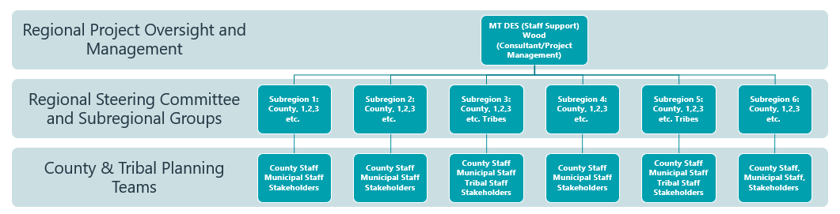
Figure 3-1 Eastern Montana Regional Hazard Mitigation Planning Committee Framework
The Emergency Management Coordinator from each participating county and tribe served on the Regional HMPC, as well as convening and facilitating a County Planning Team (CPT) or Tribal Planning Team (TPT) in concert with MT DES and the consultant team.

Government Participation
The DMA planning regulations and guidance stress that each local and tribal government seeking FEMA approval of their mitigation plan must participate in the planning effort in the following ways:
- Participate in the process as part of the Regional HMPC through participation in a CPT or TPT,
- Detail areas within the planning area where the risk differs from that facing the entire area,
- Identify specific projects to be eligible for funding, and
- Have the governing board formally adopt the plan.
For the Eastern Montana Regional HMP’s HMPC, “participation” meant:
- Providing input by attending and participating in HMPC meetings, separate side-bar meetings, or email and phone correspondence;
- Establishing/reconvening a local steering committee;
- Providing available data requested by the HMPC coordinator and planning consultant;
- Providing/updating the hazard profile and vulnerability details specific to jurisdictions;
- Developing/updating the local mitigation strategy (action items and progress);
- Advertising and assisting with the public input process;
- Reviewing and commenting on plan drafts; and
- Coordinating the formal adoption of the plan by the governing boards.
This Regional Plan includes the participation of most of the counties and the municipalities in Eastern Montana as noted in Chapter 1 and detailed further in Section 3.3.1. Documentation of participation is included in Appendix B in the form of meeting sign-in sheets, meeting summaries, monthly meeting participation, and additional documentation.

The 10-Step Planning Process
The HMPC established the planning process for the Eastern Montana Region HMP using the DMA planning requirements and FEMA’s associated guidance. This guidance is structured around a four-phase process:
- Organize Resources
- Assess Risks
- Develop the Mitigation Plan
- Implement the Plan and Monitor the Progress
Into this four-phase process, WSP integrated a more detailed 10-step planning process used for FEMA’s Community Rating System (CRS) and FMA programs. Thus, the modified 10-step process used for this plan meets the requirements of all of FEMA’s HMA grant programs, the CRS program, and flood control projects authorized by the US Army Corps of Engineers. Additionally, FEMA’s May 2023 Local Mitigation Planning Handbook recommends a nine-task process within the four-phase process. Table 3-2 summarizes the four-phase DMA process, the detailed CRS planning steps and work plan used to develop the plan, the nine handbook planning tasks from FEMA’s 2023 Local Mitigation Planning Handbook, and where the results are captured in the Plan. Tribal elements of the Regional HMP were designed to be fully compliant with the requirements of 44 CFR 201.7 as detailed in FEMA’s 2019 Tribal Multi-Hazard Mitigation Planning Guidance. The sections that follow describe each planning step in more detail.
Table 3-2 Mitigation Planning Process Used to Develop the Regional Hazard Mitigation Plan
FEMA 4 Phase Guidance | CRS Planning Steps (Activity 510) | FEMA Local Mitigation Planning Handbook Tasks (44 CFR Part 201) | Location in Plan
Phase I: Organize Resources | Step 1. Organize Resources | 1: Determine the Planning Area and Resources | Chapters 1, 2 and 3
 |  | 2: Build the Planning Team 44 CFR 201.6(c)(1) | Chapter 3, Section 3.3.1
 | Step 2. Involve the public | 3: Create an Outreach Strategy 44 CFR 201.6(b)(1) | Chapter 3, Section 3.3.1
 | Step 3. Coordinate with Other Agencies | 4: Review Community Capabilities 44 CFR 201.6(b)(2) & (3) | Chapter 3, Section 3.3.1 and annexes
Phase II: Assess Risks | Step 4. Assess the hazard | 5: Conduct a Risk Assessment 44 CFR 201.6(c)(2)(i) 44 CFR 201.6(c)(2)(ii) & (iii) | Chapter 4 and annexes
 | Step 5. Assess the problem |  | Chapter 4 and annexes
Phase III: Develop the Mitigation Strategy | Step 6. Set goals | 6: Develop a Mitigation Strategy 44 CFR 201.6(c)(3)(i); 44 CFR 201.6(c)(3)(ii); and 44 CFR 201.6(c)(3)(iii) | Chapter 5, Section 5.2
 | Step 7. Review possible activities |  | Chapter 5, Section 5.3
 | Step 8. Draft an action plan |  | Chapter 5, Section 5.3.3 and annexes
Phase IV: Adopt and Implement the Plan | Step 9. Adopt the plan | 8: Review and Adopt the Plan | Chapter 6
 | Step 10. Implement, evaluate, revise | 7: Keep the Plan Current | Chapter 6
 |  | 9: Create a Safe and Resilient Community 44 CFR 201.6(c)(4) | Chapter 6

Phase 1: Organize Resources

Planning Step 1: Organize the Planning Effort
With each jurisdiction’s commitment to developing a Regional Plan, WSP worked with MT DES and each County and Tribal Emergency Management Coordinator to establish the framework and organization for the process. Organizational efforts were initiated with each county to inform and educate the plan participants of the purpose and need for the Regional HMP. The planning consultant held an initial conference call using Microsoft Teams (Teams) to discuss the organizational aspects of the planning process with the Emergency Management Coordinators. Following FEMA planning guidance, MT DES and the consultant directed each participating county and tribe to develop their respective planning teams, comprised of representative county, tribal, and municipal staff members, prior to this meeting to ensure complete representation and active participation in the plan update process. Neighboring communities, local and regional agencies involved in hazard mitigation activities, and agencies that have the authority to regulate development as well as businesses, academia, and other private and non-profit interests were also invited to participate and provide input. Additional invitations were extended as appropriate to other federal, state, tribal, and local stakeholders, as well as to members of the public, throughout the planning process. A full list of local government departments and stakeholders that participated can be found in Appendix A. More details with documentation of participation included are in Appendix B.
Throughout the plan development process, communication amongst the CPTs and TPTs occurred through a combination of face-to-face meetings, virtual meetings, conference calls, phone interviews, planning workshops, and email correspondence. During the kickoff meeting, WSP presented information on the scope and purpose of the plan update, the participation requirements of HMPC members, and the proposed project work plan and schedule. A plan for public involvement (Step 2) and coordination with other agencies and departments (Step 3) were discussed. The HMPC reviewed the hazard identification information for each jurisdiction and the Eastern Region and refined the list of identified hazards to mirror that of the Montana Multi-Hazard Mitigation Plan. In follow-up to the meeting, participants were provided a Geographic Information Systems (GIS) needs worksheet to facilitate the collection of information needed to support the plan update, and a summary of the conference call.
Following the initial coordination efforts, a series of planning workshops were held during the plan’s development between March 2022 and August 2023. The meeting schedule and topics are listed below. In addition, monthly conference calls were held with the Emergency Management Coordinators, MT DES and WSP to discuss the process including upcoming milestones and information needs. The sign-in sheets, meeting summaries, and agendas for each of the meetings are documented in Appendix B. HMPC planning workshops were scheduled as follows.
- Workshop #1: Kickoff Meeting
- August 9, 2022
- Workshop #2: Hazard Identification and Risk Assessment and Goals Update
- December 14, 2022
- The purpose of this workshop was to review the results of the risk assessment and review and update/develop goals.
- Workshop #3: Mitigation Strategy Update
- Five in-person workshops were held in the Eastern Region:
- April 3, 2023 – Billings, Montana
- April 4, 2023 – Sidney, Montana
- April 5, 2023 – Wolf Point, Montana
- April 6, 2023 – Miles City, Montana
- April 7, 2023 – Billings, Montana
- This workshop focused on the update of the mitigation strategy and brainstorming new mitigation actions to include in the Regional HMP.
To further supplement the meetings, the WSP developed a project website to help explain the background details of the project, provide education and information on the processes of hazard mitigation planning, advertise public outreach efforts, and post-meeting materials and plan documents to be available for review. Figure 3-2 shows a snapshot of the homepage of the project website, which is also available at mitigationplanmt.com.
Figure 3-2 Montana Hazard Mitigation Project Website
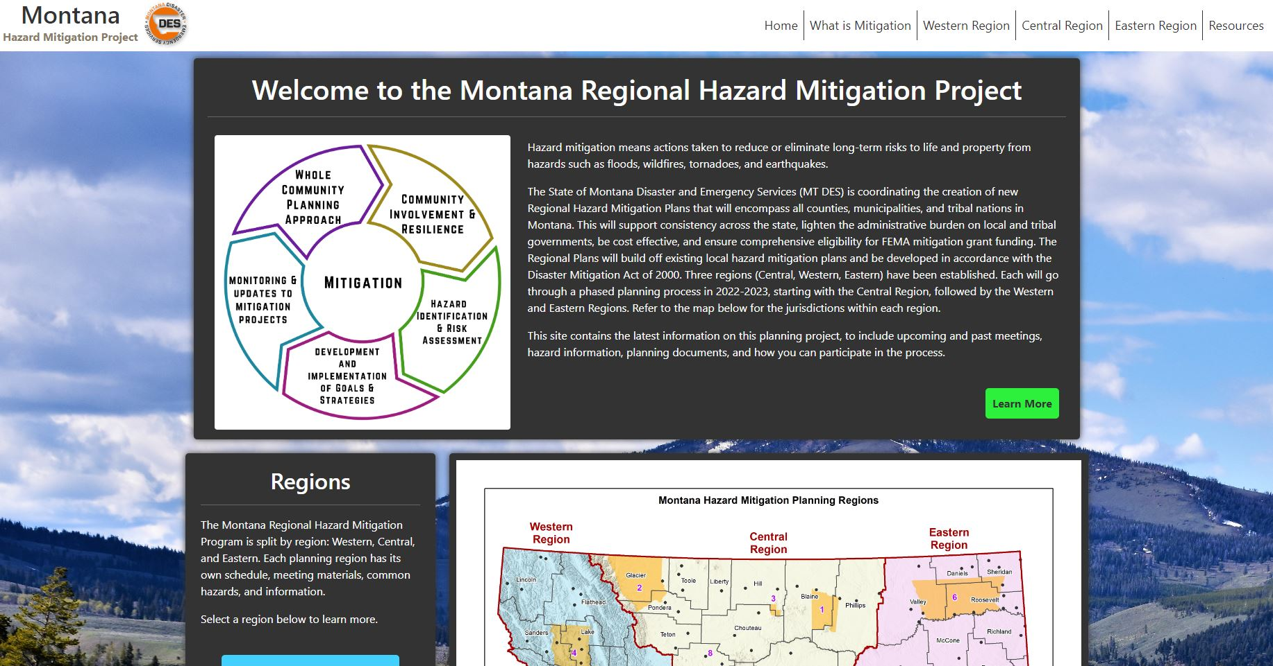
Data Source: WSP (mitigationplanmt.com)
In some cases, HMPC meetings were supplemented with additional meetings, emails, and telephone discussions to further engage the municipalities in the process. As previously noted, the Fort Peck Tribes, Northern Cheyenne Tribe, and Wheatland County elected not to participate in the Regional Plan. Wheatland County recently updated their county HMP in 2021 and had limited staff resources. The Northern Cheyenne Tribe elected not to participate due to limited staff and resources, and the Fort Peck Tribes are currently updating their plan as part of a separate process.

Planning Step 2: Involve the Public
The 2022-2023 planning process was an open one, with the public informed and involved throughout the process. In some cases, the HMPC meetings included members of the public and/or local media. Public outreach included social media notices, a public survey, and a public comment form to allow the public the opportunity to share comments on the draft plan.

2022 Public Survey
Early in the planning process, a public survey was developed as a tool to gather public input. The survey was for the public to provide feedback to the CPTs and TPTs on topics related to hazard concerns and reducing hazard impacts. The survey provided an opportunity for public input during the planning process, prior to the finalization of the plan update. The survey gathered public feedback on what hazards concern them and solicited input on strategies to reduce their impacts. The survey was released as an online tool in September 2022 and closed in December 2023. The counties and tribes provided links to the public survey by distributing it using social media, email, and posting the link on websites. In total, 407 survey responses were received and shared with the CPTs and TPTs to inform the process.
The public survey included a question on ranking hazard significance. The results generally track with the significance levels noted in Chapter Error! Reference source not found. of this Plan, with severe winter weather, severe summer weather, wildland and rangeland fire, and drought rated the most significant, and tornado and windstorms and flooding rated medium significant. The following graph is a display of the results from Question 17, which asked what types of mitigation actions should have the highest priority in the Eastern Region HMP. The results indicate that electrical power resiliency, improve reliability of communication systems, and public education awareness were popular mitigation topics with the public (
Figure 3-3). The full results of the survey are included in Appendix C.

Figure 3-3 Eastern Montana Public Survey Results

Prior to finalizing, a draft of the regional plan was made available to the public for review and comment from ____ to _____. The plan was placed on the MT DES web page, on the Montana Hazard Mitigation project website (mitigationplanmt.com) and the counties used social media and email blasts to announce the public comment period. An online feedback form was provided to collect specific comments. X comments from the public were received through the form, and X additional email comments were provided, which can be found in Appendix D. These comments were discussed with the HMP, resulting in minor clarifications and changes in a few sections of the plan to improve the accuracy of the information, and in other cases resulted in XYZ.

Planning Step 3: Coordinate with Other Departments and Agencies
Early in the planning process, the HMPC determined that data collection, mitigation strategy development, and Plan approval would be greatly enhanced by inviting state and federal agencies and organizations to participate in the process. Neighboring communities, tribal and regional agencies involved in hazard mitigation activities, agencies that have the authority to regulate development, as well as other businesses, academia, and private and NGO organizations, were also invited to provide feedback. Based on their involvement in hazard mitigation activities or their role in land stewardship in the Eastern Region, representatives from several state and federal agencies and local businesses were included in the HMPC in 2022 and are noted in Appendix A. Many of these stakeholders participated in planning meetings or were provided an opportunity to review the draft plan before it was finalized. Some of the State and Federal agencies, which were invited to participate in the process, provided data and information for the Plan update, or provided feedback on the Plan include:
- Montana Department of Natural Resources & Conservation (DNRC)
- Montana Department of Transportation
- Montana Bureau of Mines & Geology
- Montana Fish, Wildlife, & Parks
- FEMA Region VIII
- EPA
- US Forest Service
- US Air Force
- Bureau of Indian Affairs
- Bureau of Land Management
- Bureau of Reclamation
- NOAA/NWS
- US Army Corps of Engineers

Coordination with certain agencies occurred on a regular basis during the planning process, including a bi-weekly (and weekly in the initial months of the project) coordination call with WSP, MT DES and other stakeholders. Other federal stakeholders that participated in these meetings included FEMA Region VIII, the Environmental Protection Agency (EPA), and the US Army Corps of Engineers (USACE). Other stakeholders included private NGOs (i.e., Headwaters Economics), and a consulting firm involved in the update of the Montana State Multi-Hazard Mitigation Plan. USACE representatives also participated in regional mitigation strategy workshops, including providing information on funding programs and suggestions for partnerships on mitigation actions.

Other Community Planning Efforts and Hazard Mitigation Activities
Coordination with other community planning efforts is an important aspect of mitigation planning. Hazard mitigation planning involves identifying existing policies, tools, and actions that will reduce a community’s risk and vulnerability to natural hazards. Each county, the tribes, and most municipalities in the Region use a variety of comprehensive planning mechanisms, such as master plans and ordinances, to guide growth and development. Integrating existing planning efforts and mitigation policies and action strategies into this plan establishes a credible and comprehensive plan that ties into and supports other community programs. The development of this plan incorporated information from the following existing plans, studies, reports, and initiatives as well as other relevant data from neighboring communities and other jurisdictions. Examples of this include.
- County comprehensive plans
- Community Wildfire Protection Plans (CWPPs)
- Montana State Multi-Hazard Mitigation Plan (2018)
- Existing Local and Tribal HMPs
- Montana Forest Action Plan (2020)
- Montana Climate Solutions Plan (2020)
Other documents were reviewed and cited, as appropriate, during the collection of data to support Planning Steps 4 and 5, which include the hazard identification, vulnerability assessment, and capability assessment, are noted in Appendix E References.

Phase 2: Assess Risks

Planning Steps 4 and 5: Identify the Hazards and Assess the Risks
WSP led the HMPC and CPT/TPTs to identify and document all the hazards that have, or could, impact the planning area. The existing county and tribal HMPs, and the Montana State Multi-Hazard Mitigation Plan provided a knowledge basis for many of the hazard profiles. Where data permitted, GIS was used to display, analyze, and quantify hazards and vulnerabilities. Quantitative spatial analyses for dam inundation, flood, earthquake, and wildfire hazards were performed by WSP that included an analysis of flood risk based on the Digital Flood Insurance Rate Maps (DFIRMs), where available. A more detailed description of the risk assessment process and the results are included in Chapter Error! Reference source not found. Hazard Analysis and Risk Assessment.
Also included in the Eastern Regional HMP is a capability assessment to review and document the planning area’s current capabilities to mitigate risk and vulnerability from hazards. By collecting information about existing government programs, policies, regulations, ordinances, and emergency plans, the HMPC can assess those activities and measures already in place that contribute to mitigating some of the risks and vulnerabilities identified. The results of the updated capability assessment are captured in each annex and addendum.
During this phase, the tribes and participating jurisdictions reviewed hazard significance levels, as described in Chapter 4, to determine if any changes in priorities were needed. Additional feedback on priority levels was solicited during Workshop #2, using an online polling tool and in-person during Workshop #3.

Phase 3: Develop the Mitigation Plan

Planning Steps 6 and 7: Set Goals and Review Possible Activities
WSP facilitated a week of discussion sessions (Workshop #3) with the HMPC that described the purpose and the process of developing planning goals, a comprehensive range of mitigation alternatives, and a method of selecting and defending recommended mitigation actions using a series of selection criteria. This process was used to update and enhance the mitigation action plan for each jurisdiction and tribe, which is the essence of the planning process and one of the most important outcomes of this effort. The action plans are detailed in each county and tribe annex and addendum; the process used to identify and prioritize mitigation actions is described in greater detail in Chapter 5 Mitigation Strategy.
During this phase the tribes and participating jurisdictions reviewed mitigation action priority levels, as described in Chapter 5, to determine if any changes in priorities were needed using a mitigation action status tool. The tribes and participating jurisdictions also developed and prioritized new mitigation actions. Figure 3-4 shows the CPTs and TPTs developing new mitigation actions during the Workshop #3 series in Eastern Montana.
Figure 3-4 Eastern Montana HMP Workshops – Mitigation Strategy Update
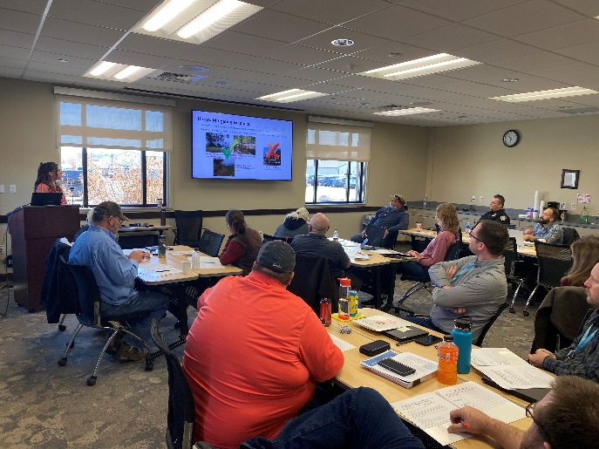
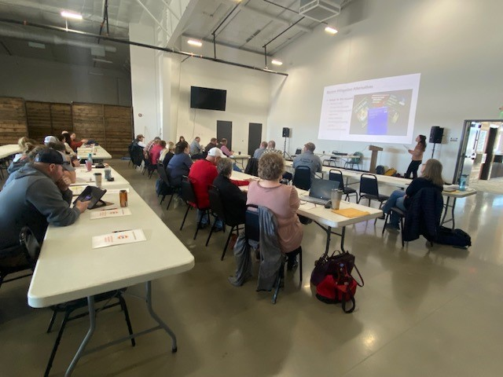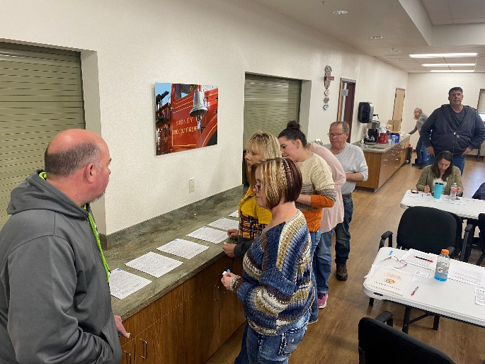
Data Source: WSP 2023

Planning Step 8: Draft an Action Plan
Based on input from the HMPC regarding the draft risk assessment and the goals and activities identified in Planning Steps 6 and 7, WSP produced a complete first draft of the Eastern Regional Plan. This complete draft was shared for HMPC and CPT/LPT review and comment by email from the consultant and posted on the project website and cloud-based share drive. Comments were integrated into the second draft, which was advertised and distributed to collect public input and comments. Other agencies and neighboring county Emergency Management Coordinators were also invited to comment on this draft. WSP integrated comments and issues from the public, as appropriate, along with additional internal review comments and produced a final draft for MT DES and FEMA Region VIII to review and approve, contingent upon final adoption by the governing boards of each participating jurisdiction.

Phase 4: Implement the Plan and Monitor Progress

Planning Step 9: Adopt the Plan
To secure buy-in and officially implement the plan, the plan was adopted by the governing boards of each participating jurisdiction. As the adoption process follows the FEMA plan review and approval, copies of the adoption resolution will be included electronically in Appendix D.

Planning Step 10: Implement, Evaluate, and Revise the Plan
The true worth of any mitigation plan is in the effectiveness of its implementation. Each recommended action includes key descriptors, such as a lead manager and possible funding sources, to help initiate implementation. Progress on the implementation of specific actions identified in the plan is captured in a discussion and the mitigation action plan summary table in Chapter 5 Mitigation Strategy. An overall implementation strategy is described in Chapter 6 Plan Adoption, Implementation and Maintenance.
Finally, there are numerous organizations within the Eastern Region whose goals and interests interface with hazard mitigation. Coordination with these other planning efforts, as addressed in Planning Step 3, is important to the ongoing success of this plan, and mitigation in Eastern Montana and is addressed further in Chapter 6. A plan update and maintenance schedule and a strategy for continued public involvement are also included in Chapter 6, and specifics are also in the annexes for the participating counties and tribes.

Tribal Mitigation Planning Process
The Eastern Montana Regional HMP meets the requirements for Tribal Mitigation Plans described in Title 44 of the Code of Federal Regulations, Section 201.7 (44 CFR § 201.7). Under the Sandy Recovery Improvement Act of 2013, federally recognized tribal governments could obtain their major disaster declaration for the first time, enabling them to apply to FEMA for disaster assistance independent of the state obtaining a declaration. The Tribal Mitigation Planning Handbook outlines a 7-step planning process for the development of mitigation plans, which meet the needs of tribal governments. These 7 steps are summarized in Table 3-3.
Table 3-3 Tribal Mitigation Planning 7-Step Process
Planning Step | Title | Description
1 | Describe your community | Describe the planning area, Tribal assets, and any unique characteristics of your Tribe.
2 | Identify your hazards | Figure out what natural hazards could occur in your planning area.
3 | Explain impacts that hazards can have on the community | Describe what the natural hazards could do to your people, property, and land and determine the Tribe’s biggest hazard concerns.
4 | Review your current capability to mitigate the impacts | Inventory your Tribe’s plans, policies, and programs that could be used to protect your community.
5 | Develop the strategy | Keeping in mind your risks and your capabilities, identify your Tribe’s mitigation goals and actions.
6 | Develop an action plan | Prioritize your actions and develop the details to assist with implementation.
7 | Keep track of progress | Observe and record progress in implementing your mitigation program using a defined method and schedule.

EPA Regional Resilience Toolkit
The EPA, in partnership with FEMA, has developed the Regional Resilience Toolkit to focus on the development of resilient communities on the regional scale at which disasters happen. As stated in the toolkit, with more and more communities facing the effects of disasters, decision-makers and community members need tools and guidance to help them take action that can protect them from natural disasters while also creating great places to live, work, and play. This Regional Resilience Toolkit provides:
- A coordinated process for meeting many different state and federal planning requirements.
- Communication and outreach guidance and resources for engaging a broad coalition of stakeholders across a region.
- Guidance for project teams who are conducting vulnerability assessments, writing required plans, and implementing projects.
- Clear information and tools that can be used with an advisory group and bring in decision-makers and community leaders to guide the overall action plan and ensure its successful implementation.
- Detailed appendices with worksheets to help inform and guide work, as well as additional information and resources for each step.
The toolkit includes five steps designed so that users can follow at any point of the process depending on their progress with community resilience planning. These five steps are shown in Figure 3-5 below:
Figure 3-5 EPA Regional Resilience Toolkit Planning Steps
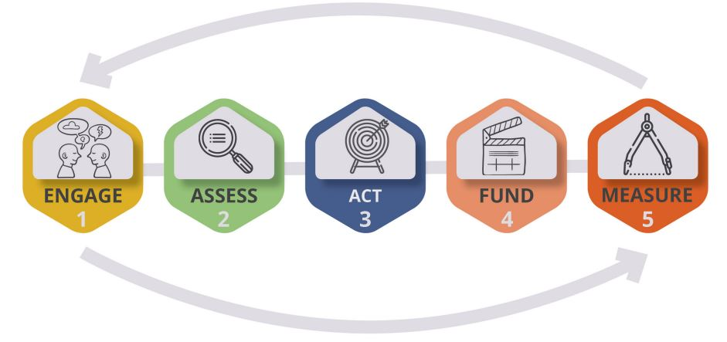
Source: EPA Regional Resilience Toolkit, https://www.epa.gov/smartgrowth/regional-resilience-toolkit
The toolkit also relies in part on engaging state and federal partners who have funding, policies, and programs intended to support local efforts to create sustainable and resilient communities, helping to supplement the mitigation strategy of this regional HMP. Like the FEMA mitigation planning process, the steps of the resilience toolkit are intended to ideally work in a continuous loop improving planning and community resilience over time. This is a valuable tool for the development of the Eastern Montana Regional HMP, due to the large scale of the planning area and the history of hazards that have had regional impacts.

Hazard Analysis and Risk Assessment PLACEHOLDER

Mitigation Strategy
Local Plan Requirement §201.6(c)(3): [The plan shall include] a mitigation strategy that provides the jurisdiction’s blueprint for reducing the potential losses identified in the risk assessment, based on existing authorities, policies, programs and resources, and its ability to expand on and improve these existing tools. This section shall include:
(i) A description of mitigation goals to reduce or avoid long-term vulnerabilities to the identified hazards.
(ii) A section that identifies and analyzes a comprehensive range of specific mitigation actions and projects being considered to reduce the effects of each hazard, with particular emphasis on new and existing buildings and infrastructure.
(iii) An action plan describing how the actions identified in section (c)(3)(ii) will be prioritized, implemented, and administered by the local jurisdiction. Prioritization shall include a special emphasis on the extent to which benefits are maximized according to a cost-benefit review of the proposed projects and their associated costs.
Tribal Requirement §201.7(c)(3): A mitigation strategy that provides the Indian tribal government's blueprint for reducing the potential losses identified in the risk assessment, based on existing authorities, policies, programs and resources, and its ability to expand on and improve these existing tools. This section shall include:
(i): A description of mitigation goals to reduce or avoid long-term vulnerabilities to the identified hazards.
(ii): A section that identifies and analyzes a comprehensive range of specific mitigation actions and projects being considered to reduce the effects of each hazard, with particular emphasis on new and existing buildings and infrastructure.
(iii): An action plan describing how the actions identified in paragraph (c)(3)(ii) of this section will be prioritized, implemented, and administered by the Indian Tribal government.

Mitigation Strategy: Overview
This section describes the mitigation strategy process and mitigation action plan for the Eastern Montana Region HMP. It describes how the participating jurisdictions in the Region met the following requirements from the 10-step planning process:
- Planning Step 6: Set Goals
- Planning Step 7: Review Possible Activities
- Planning Step 8: Draft an Action Plan
The results of the planning process, the risk assessment, the goal setting, the identification of mitigation actions, and the hard work of each jurisdiction’s CPT/TPT led to this mitigation strategy and action plan. Section 5.2 below identifies the goals of this plan and Section 5.4 describes the mitigation action plan.

Mitigation Goals
Up to this point in the planning process, each jurisdiction’s CPT/TPT has organized resources, assessed hazards and risks, and documented mitigation capabilities. The resulting goals and mitigation actions were reviewed and updated based on these tasks. During the 2022-2023 update of this plan, each CPT/TPT held a series of meetings designed to achieve a collaborative mitigation strategy as described further throughout this section.
Goals were defined for the purpose of this mitigation plan as broad-based public policy statements that:
- Represent basic desires of the community;
- Encompass all aspects of community, public and private;
- Are nonspecific, in that they refer to the quality (not the quantity) of the outcome;
- Are future-oriented, in that they are achievable in the future; and
- Are time-independent, in that they are not scheduled events.
Goals are stated without regard to implementation. Implementation cost, schedule, and means are not considered. Goals are defined before considering how to accomplish them so that they are not dependent on the means of achievement. Goal statements form the basis for objectives and actions that will be used as means to achieve the goals.
During the mitigation strategy workshops held in April 2023, the jurisdictions reviewed the results of the hazard identification, vulnerability assessment, and capability assessment. They then reviewed the goals of the previous county and tribal hazard mitigation plans in the Eastern Region, as well as the Montana State Multi-Hazard Mitigation Plan. This analysis of the risk assessment identified areas where improvements could be made and provided the framework for the counties and tribes to update planning goals and to base the development of new or updated mitigation strategies for the counties and tribes in the Eastern Region. The participating jurisdictions decided to collaborate and develop a set of new, uniform goals, which were adopted by all counties in the Eastern Region:
Goal 1: Reduce impacts to people, property, the environment, and the economy from hazards by implementing whole-community risk reduction and resilience strategies.
Goal 2: Protect community lifelines and critical infrastructure to ensure the continuity of essential services during and after a disaster.
Goal 3: Support education and outreach to the public through improved communications and capacity building that enhances resilience among underserved communities.
Goal 4: Promote regional cooperation and leverage partnerships with the private sector, non-profit organizations, and other key stakeholder groups in mitigation solutions.
Goal 5: Sustain and enhance jurisdictional capabilities and resources to enact and implement mitigation activities.
Goal 6: Integrate hazard mitigation into other plans, processes, and regulations.
Goal 7: Ensure local mitigation programs address underrepresented groups and protect socially vulnerable populations.
Goal 8: Incorporate the potential impacts of climate change into all mitigation activities.
Objectives are an optional intermediate step between goals and mitigation actions that define strategies to attain the goals and are more specific and measurable. After discussion, the HMPC decided not to include regional objectives. Each county and tribe were given the opportunity to set objectives to meet their unique situation and complement the regional goals. See Section 6 of each jurisdictional annex or addendum for details.

Identification and Analysis of Mitigation Actions
The next step in the mitigation strategy is to identify and analyze a comprehensive range of specific mitigation actions and projects to reduce the effects of each hazard on new and existing buildings and infrastructure. During the 2022-2023 Regional HMP process, each jurisdiction’s CPT/TPT analyzed viable mitigation options by hazard that supported the identified goals. The CPTs/TPTs were provided with the following list of categories of mitigation actions, which originate from the CRS:
- Plan and Regulations (Prevention): Administrative or regulatory actions or processes that influence the way land and buildings are developed and built.
- Property Protection: Actions that involve the modification of existing buildings or structures to protect them from a hazard or remove them from the hazard area.
- Structural and Infrastructure Projects: Actions that involve the construction of structures to reduce the impact of a hazard.
- Natural Resource Protection: Actions that, in addition to minimizing hazard losses, also preserve or restore the functions of natural systems.
- Public Information/Education and Awareness: Actions to inform and educate citizens, elected officials, and property owners about the hazards and potential ways to mitigate them.
- Emergency Services: Actions that protect people and property during and immediately after a disaster or hazard event.
To identify and select mitigation actions in support of the mitigation goals, the HMPC evaluated each hazard identified and profiled in Chapter 3.4. A link to reference documents titled “Mitigation Ideas” and “Mitigation Action Portfolio” developed by FEMA was referenced in the meeting presentation and made available as hard copies distributed during Workshop #3 to support the planning exercises. These documents list common alternatives for mitigation by hazard and best practices. The jurisdictions considered both future and existing buildings in considering possible mitigation actions. A facilitated discussion then took place to examine and analyze the options.
The mitigation strategy is based on existing local and tribal authorities, policies, programs, and resources, as well as the ability to expand on and improve these existing tools. As part of the Regional HMP development, the CPTs and TPTs reviewed existing capabilities for reducing long-term vulnerability to hazards. Those capabilities are noted by the jurisdiction in the county and reservation annexes and addendums and can be assessed to identify gaps to be addressed and strengths to enhance through new mitigation actions. For instance, gaps in the design or enforcement of existing regulations be addressed through additional personnel or a change in procedure or policy.
Based upon the key issues identified in the risk assessment, including the capability assessment, the counties and tribes came to a consensus on proposed mitigation actions for each hazard for their jurisdictions. Certain hazards’ impacts were best reduced through multi-hazard actions. A lead for each new action, where applicable, was identified to provide additional details on the project so they could be captured in the plan. Final action strategies are summarized in Section 5.4 and detailed within the respective jurisdictional annexes.

Prioritization Process
Once the mitigation actions were identified, the CPTs and TPTs were provided FEMA’s recommended prioritization criteria STAPLEE to assist in deciding why one recommended action might be more important, more effective, or more likely to be implemented than another. STAPLEE is an acronym for the following:
- Social: Does the measure treat people fairly? (e.g., different groups, different generations)
- Technical: Is the action technically feasible? Does it solve the problem?
- Administrative: Are there adequate staffing, funding, and other capabilities to implement the project?
- Political: Who are the stakeholders? Will there be adequate political and public support for the project?
- Legal: Does the jurisdiction have the legal authority to implement the action? Is it legal?
- Economic: Is the action cost-beneficial? Is there funding available? Will the action contribute to the local economy?
- Environmental: Does the action comply with environmental regulations? Will there be negative environmental consequences from the action?
Other criteria used to assist in evaluating the priority of a mitigation action included:
- Does the action address hazards or areas with the highest risk?
- Does the action protect lives?
- Does the action protect infrastructure, community assets or critical facilities?
- Does the action meet multiple objectives?
At the mitigation strategy workshops, the counties and tribes used STAPLEE to determine which of the newly identified actions were most likely to be implemented and effective. Keeping the STAPLEE criteria in mind, each jurisdiction prioritized the new mitigation actions by giving an indication of relative priority, which was then translated into ‘high,’ ‘medium’ and ‘low.’ The results of the STAPLEE evaluation process produced prioritized mitigation actions for implementation within the planning area. Continued actions were also assessed to see if priority changes were needed; most of these remained the same but in some cases, priorities were changed.
The process of identification and analysis of mitigation alternatives allowed the county and tribal planning teams to come to a consensus and prioritize recommended mitigation actions for their jurisdictions. During the voting process, emphasis was placed on the importance of a benefit-cost review in determining project priority as this is a requirement of the DMA regulations; however, this was a planning-level analysis as opposed to a quantitative analysis. A quantitative cost-benefit analysis will be considered in additional detail when seeking FEMA mitigation grant funding for eligible projects identified in this plan.
Each mitigation action developed for this plan contains a brief description of the problem and proposed project, the entity with primary responsibility for implementation, a cost estimate, and a schedule for implementation. The development of these project details further informed the determination of a high, medium, or low priority for each. During the plan update, the jurisdictions in the Eastern Region identified some mitigation actions to be carried forward from their previous county HMPs. Priority levels on these actions were revisited during Workshop #3 and through the distribution of a Mitigation Action Tracker tool and, in some cases, modified to reflect current priorities based on the STAPLEE principles.

Mitigation Action Plan
This section outlines the development of the mitigation action plan. The action plan consists of the specific projects, or actions, designed to meet the plan's goals. Over time the implementation of these projects will be tracked as a measure of demonstrated progress on meeting the plan's goals.

Progress on Previous Mitigation Actions
This Eastern Regional HMP represents a plan update for all counties and tribes. As part of the update process, the jurisdictions reviewed actions identified in their previous plans to assess progress on implementation. These reviews were completed using worksheets to capture information on each action including if the action was completed or deferred to the future. Actions that were not completed were discussed for continued relevance and were either continued into the Regional Plan or in some cases recommended for deletion.
The participating jurisdictions have been working steadily towards meeting the goals of their previous plans. While several remain to be completed, many were noted as in-progress. Progress on mitigation actions previously identified in these planning mechanisms is detailed in the jurisdictional annexes. These action plans were also shared amongst the Regional Plan participants to showcase progress and stimulate ideas amongst the respective planning committees in each county and tribe. Reasons that some actions have not been completed include low priority, lack of funding, or lack of administrative resources.
Table 5-1 summarizes the progress in implementing mitigation actions by tribe and county (including the municipalities). In total, 29 actions have been completed, and 24 were deleted as being no longer relevant or feasible. A total of 948 actions were carried over into the Regional Plan, along with 104 new actions developed during the planning effort.
Table 5-1 Mitigation Action Progress Summary by Jurisdiction
County/Reservation | Completed | Deleted | Continuing | New Actions in 2023 | Total Continuing and New Actions
Big Horn | 0 | 0 | 79 | 2 | 81
Carbon | 1 | 3 | 69 | 12 | 81
Carter | 0 | 0 | 19 | 6 | 25
Crow Tribe | 0 | 0 | 13 | 1 | 14
Custer | 2 | 0 | 96 | 6 | 102
Daniels | 5 | 2 | 20 | 7 | 27
Dawson | 0 | 0 | 32 | 1 | 33
Fallon | 0 | 0 | 22 | 3 | 25
Garfield | 0 | 0 | 10 | 1 | 11
Golden Valley | 1 | 0 | 61 | 1 | 62
McCone | 2 | 2 | 24 | 1 | 25
Musselshell | 0 | 0 | 74 | 2 | 76
Powder River | 0 | 0 | 12 | 2 | 14
Prairie | 3 | 1 | 8 | 6 | 14
Richland | 1 | 0 | 33 | 2 | 35
Roosevelt | 3 | 0 | 34 | 3 | 37
Rosebud | 0 | 0 | 39 | 0 | 39
Sheridan | 3 | 0 | 21 | 4 | 25
Stillwater | 0 | 16 | 43 | 17 | 60
Treasure | 2 | 0 | 55 | 1 | 56
Valley | 6 | 0 | 70 | 18 | 88
Wibaux | 0 | 0 | 27 | 3 | 30
Yellowstone | 0 | 0 | 87 | 5 | 92
Total | 29 | 24 | 948 | 104 | 1,052
The following table summarizes the mitigation actions that address each hazard relevant to that jurisdiction.
County/Tribe LPTs – Please note there are zeros (“0”) in various columns for jurisdictions where the specific hazard noted in the column was not a priority in that jurisdiction, the jurisdiction did not have a mitigation action tied to the specific hazard profiled, or the jurisdiction needs to confirm the hazard is not a new priority and they do not need to develop a “new” mitigation action.
Table 5-2 Mitigation Actions by Hazard and Jurisdiction
County/Reservation | Communicable Disease | Cyber-Attack | Dam Failure | Drought | Earthquake | Flooding | Hazmat Incident | Landslide | Severe Summer Weather | Severe Winter Weather | Human Conflict | Tornadoes & Windstorms | Transportation Accidents | Volcanic Ash | Wildland and Rangeland Fire
Big Horn County | 13 | 10 | 19 | 5 | 15 | 23 | 16 | 12 | 19 | 19 | 20 | 15 | 13 | 16 | 36
City of Hardin | 7 | 4 | 9 | 1 | 6 | 10 | 9 | 5 | 10 | 10 | 10 | 7 | 4 | 7 | 15
Town of Lodge Grass | 7 | 3 | 10 | 0 | 8 | 13 | 10 | 7 | 12 | 11 | 12 | 8 | 6 | 8 | 19
Carbon County | 2 | 2 | 6 | 4 | 5 | 12 | 8 | 5 | 6 | 6 | 5 | 4 | 4 | 4 | 24
Town of Bearcreek | 0 | 0 | 0 | 1 | 0 | 1 | 0 | 0 | 0 | 0 | 0 | 0 | 0 | 0 | 2
Town of Bridger | 0 | 0 | 0 | 0 | 0 | 1 | 0 | 0 | 0 | 0 | 0 | 0 | 0 | 0 | 0
Town of Fromberg | 0 | 1 | 1 | 2 | 1 | 2 | 0 | 0 | 1 | 1 | 1 | 1 | 0 | 1 | 2
Town of Joliet | 0 | 2 | 2 | 1 | 2 | 6 | 0 | 0 | 3 | 3 | 2 | 2 | 0 | 2 | 2
Town of Red Lodge | 0 | 0 | 2 | 1 | 1 | 8 | 1 | 1 | 2 | 0 | 0 | 1 | 0 | 1 | 5
Carter County | 3 | 3 | 1 | 2 | 1 | 3 | 5 | 1 | 2 | 3 | 3 | 1 | 1 | 1 | 4
Town of Ekalaka | 1 | 2 | 1 | 1 | 1 | 4 | 1 | 1 | 2 | 2 | 2 | 1 | 2 | 1 | 1
Crow Tribe | 3 | 1 | 6 | 0 | 6 | 8 | 6 | 5 | 6 | 6 | 5 | 7 | 2 | 6 | 9
Custer County | 21 | 9 | 19 | 8 | 17 | 24 | 21 | 16 | 25 | 25 | 21 | 18 | 20 | 18 | 32
City of Miles City | 20 | 8 | 16 | 7 | 15 | 33 | 22 | 14 | 23 | 24 | 21 | 16 | 21 | 16 | 28
Town of Ismay | 20 | 4 | 14 | 5 | 13 | 15 | 17 | 13 | 19 | 19 | 14 | 14 | 16 | 14 | 17
Daniels County | 1 | 0 | 5 | 0 | 0 | 5 | 3 | 0 | 4 | 4 | 1 | 5 | 0 | 0 | 10
City of Scobey | 1 | 0 | 4 | 0 | 0 | 7 | 2 | 0 | 3 | 3 | 0 | 4 | 0 | 0 | 8
Town of Flaxville | 1 | 0 | 3 | 0 | 0 | 5 | 2 | 0 | 3 | 4 | 0 | 4 | 0 | 0 | 8
Dawson County | 1 | 1 | 3 | 1 | 2 | 14 | 7 | 2 | 9 | 8 | 3 | 2 | 1 | 2 | 3
City of Glendive | 0 | 1 | 2 | 1 | 1 | 11 | 2 | 0 | 4 | 2 | 2 | 1 | 0 | 1 | 1
Town of Richey | 0 | 0 | 1 | 1 | 0 | 2 | 1 | 0 | 4 | 2 | 1 | 1 | 0 | 0 | 0
Fallon County | 4 | 5 | 5 | 4 | 2 | 4 | 5 | 2 | 5 | 5 | 5 | 2 | 3 | 2 | 5
City of Baker | 2 | 3 | 5 | 3 | 2 | 4 | 2 | 2 | 3 | 3 | 3 | 2 | 2 | 2 | 2
Town of Plevna | 2 | 2 | 2 | 2 | 2 | 2 | 2 | 2 | 2 | 2 | 2 | 2 | 2 | 2 | 2
Garfield County | 1 | 1 | 2 | 1 | 2 | 4 | 3 | 3 | 3 | 4 | 2 | 2 | 2 | 2 | 4
Town of Jordan | 1 | 1 | 2 | 1 | 2 | 4 | 3 | 2 | 2 | 3 | 2 | 2 | 2 | 2 | 4
Golden Valley County | 9 | 8 | 10 | 7 | 8 | 15 | 8 | 6 | 15 | 15 | 11 | 8 | 9 | 8 | 20
Town of Ryegate | 8 | 6 | 6 | 4 | 5 | 10 | 5 | 4 | 11 | 11 | 7 | 5 | 4 | 5 | 15
Town of Lavina | 8 | 7 | 7 | 4 | 6 | 11 | 5 | 4 | 11 | 11 | 9 | 6 | 4 | 6 | 14
McCone County | 5 | 0 | 12 | 0 | 0 | 14 | 11 | 7 | 15 | 14 | 9 | 0 | 0 | 0 | 12
Town of Circle | 1 | 0 | 2 | 0 | 0 | 2 | 1 | 1 | 2 | 2 | 1 | 0 | 0 | 0 | 1
Musselshell County | 9 | 6 | 14 | 6 | 11 | 21 | 14 | 10 | 17 | 17 | 13 | 11 | 13 | 10 | 24
Town of Melstone | 8 | 3 | 6 | 4 | 4 | 4 | 6 | 4 | 7 | 7 | 7 | 4 | 5 | 4 | 11
Town of Roundup | 9 | 4 | 8 | 5 | 6 | 15 | 10 | 6 | 11 | 11 | 9 | 6 | 8 | 6 | 11
Powder River County | 1 | 1 | 2 | 1 | 2 | 5 | 4 | 2 | 3 | 3 | 1 | 2 | 1 | 1 | 4
Town of Broadus | 1 | 1 | 1 | 1 | 1 | 6 | 3 | 1 | 3 | 2 | 1 | 1 | 1 | 1 | 1
Prairie County | 0 | 2 | 2 | 2 | 2 | 3 | 0 | 0 | 3 | 5 | 2 | 2 | 0 | 2 | 2
Town of Terry | 0 | 0 | 0 | 0 | 0 | 0 | 0 | 0 | 0 | 0 | 0 | 0 | 0 | 0 | 0
Richland County | 2 | 1 | 1 | 3 | 1 | 5 | 3 | 2 | 7 | 9 | 2 | 2 | 1 | 1 | 2
Town of Fairview | 0 | 0 | 0 | 0 | 0 | 1 | 1 | 0 | 6 | 8 | 1 | 2 | 0 | 0 | 0
Town of Sidney | 0 | 0 | 0 | 0 | 1 | 9 | 3 | 0 | 12 | 14 | 2 | 1 | 0 | 0 | 2
Roosevelt County | 8 | 0 | 6 | 0 | 7 | 10 | 8 | 0 | 10 | 10 | 1 | 1 | 1 | 0 | 8
City of Wolf Point | 10 | 0 | 6 | 0 | 8 | 10 | 8 | 0 | 10 | 10 | 0 | 0 | 0 | 0 | 7
City of Polar | 9 | 0 | 6 | 0 | 8 | 10 | 7 | 0 | 10 | 10 | 0 | 0 | 0 | 0 | 7
Town of Bainville | 9 | 0 | 7 | 0 | 8 | 8 | 8 | 0 | 10 | 10 | 0 | 0 | 0 | 0 | 7
Town of Culberson | 8 | 0 | 5 | 0 | 7 | 9 | 8 | 0 | 9 | 9 | 0 | 0 | 0 | 0 | 7
Town of Froid | 10 | 0 | 6 | 0 | 8 | 10 | 9 | 0 | 11 | 11 | 1 | 1 | 0 | 0 | 8
Rosebud County | 5 | 1 | 8 | 5 | 7 | 9 | 9 | 7 | 9 | 7 | 5 | 7 | 7 | 4 | 13
City of Colstrip | 4 | 0 | 7 | 5 | 6 | 6 | 8 | 6 | 7 | 6 | 3 | 6 | 4 | 3 | 10
City of Forsyth | 4 | 2 | 9 | 4 | 8 | 10 | 7 | 8 | 9 | 8 | 4 | 8 | 4 | 3 | 12
Sheridan County | 5 | 1 | 3 | 1 | 0 | 9 | 5 | 0 | 7 | 7 | 4 | 7 | 1 | 0 | 5
City of Plentywood | 5 | 1 | 3 | 1 | 0 | 6 | 3 | 0 | 6 | 7 | 3 | 5 | 1 | 0 | 8
Town of Medicine Lake | 6 | 1 | 3 | 1 | 0 | 7 | 4 | 0 | 4 | 4 | 5 | 4 | 1 | 0 | 10
Town of Outlook | 5 | 1 | 3 | 1 | 0 | 9 | 5 | 0 | 7 | 7 | 4 | 7 | 1 | 0 | 11
Town of Westby | 5 | 1 | 3 | 1 | 0 | 9 | 5 | 0 | 7 | 7 | 4 | 7 | 1 | 0 | 11
Stillwater County | 6 | 10 | 16 | 3 | 14 | 24 | 13 | 13 | 18 | 17 | 17 | 14 | 9 | 11 | 29
Town of Columbus | 5 | 6 | 5 | 2 | 4 | 12 | 4 | 2 | 9 | 7 | 6 | 4 | 2 | 3 | 12
Treasure County | 8 | 5 | 13 | 7 | 10 | 18 | 14 | 10 | 14 | 14 | 11 | 11 | 8 | 8 | 21
Town of Hysham | 8 | 6 | 10 | 6 | 9 | 14 | 10 | 8 | 12 | 12 | 12 | 10 | 7 | 9 | 12
Valley County | 9 | 0 | 0 | 0 | 9 | 25 | 16 | 0 | 18 | 18 | 0 | 16 | 1 | 0 | 23
City of Glasgow | 8 | 0 | 0 | 0 | 8 | 25 | 13 | 0 | 11 | 11 | 0 | 11 | 0 | 0 | 18
Town of Fort Peck | 9 | 0 | 0 | 0 | 9 | 17 | 15 | 0 | 14 | 14 | 0 | 14 | 0 | 0 | 24
Town of Nashua | 9 | 0 | 0 | 0 | 9 | 27 | 16 | 0 | 16 | 16 | 0 | 16 | 0 | 0 | 22
Town of Opheim | 4 | 1 | 1 | 0 | 4 | 3 | 1 | 0 | 4 | 5 | 1 | 5 | 0 | 1 | 7
Wibaux County | 3 | 2 | 4 | 4 | 4 | 11 | 11 | 3 | 13 | 12 | 5 | 10 | 4 | 4 | 11
Town of Wibaux | 1 | 2 | 2 | 1 | 2 | 2 | 1 | 1 | 2 | 2 | 2 | 2 | 1 | 2 | 2
Yellowstone County | 9 | 7 | 12 | 3 | 11 | 22 | 17 | 10 | 18 | 17 | 15 | 11 | 6 | 9 | 23
City of Billings | 9 | 6 | 10 | 4 | 9 | 29 | 15 | 8 | 15 | 14 | 13 | 9 | 5 | 7 | 18
Town of Broadview | 9 | 4 | 8 | 1 | 8 | 10 | 9 | 6 | 14 | 13 | 10 | 8 | 5 | 7 | 16
Town of Laurel | 9 | 6 | 9 | 2 | 8 | 15 | 15 | 6 | 14 | 13 | 12 | 8 | 5 | 7 | 16
Total | 371 | 165 | 376 | 141 | 336 | 722 | 486 | 228 | 603 | 596 | 350 | 374 | 221 | 230 | 740
See the jurisdictional annexes and addendums for their list of mitigation actions, as well as more details on progress on implementation of previous actions.

Continued Compliance with NFIP
Given the significance of the flood hazard throughout the planning area, an emphasis will be placed on continued compliance with the National Flood Insurance Program (NFIP). Jurisdictions that participate in the NFIP are noted in the respective annexes’ and addendums’ Capability Assessment and will continue to make every effort to remain in good standing with the program. This includes continuing to comply with the NFIP’s standards for adopting floodplain maps and maintaining and periodically updating local floodplain regulations. Actions related to continued compliance include:
- Continued designation of a local floodplain manager whose responsibilities include reviewing floodplain development permits to ensure compliance with the local floodplain management ordinances and rules;
- Suggest changes to improve enforcement of and compliance with regulations and programs;
- Participate in Flood Insurance Rate Map (FIRMs) updates by adopting new maps or amendments to maps;
- Utilize DFIRMs in conjunction with GIS to improve floodplain management, such as improved risk assessment and tracking of floodplain permits;
- Promote and disperse information on the benefits of flood insurance.
Also, to be considered are the flood mitigation actions contained in this Eastern Regional Plan that support the ongoing efforts by participating jurisdictions to minimize the risk and vulnerability of the community to the flood hazard, and to enhance their overall floodplain management program.

Mitigation Action Plan
The action plan presents the recommendations developed by the county and tribal planning teams, outlining how each jurisdiction and the Region can reduce the risk and vulnerability of people, property, infrastructure, and natural and cultural resources to future disaster losses. The mitigation actions developed by each participating jurisdictions are detailed in the jurisdictional annexes in Section 10. These details include the action description, hazard(s) mitigated, lead and partner agencies responsible for initiating implementation, costs, and timeline. Many of the action items included in this plan are a collaborative effort among local, state, tribal, and federal agencies, and stakeholders in the planning area.
The actions included in this mitigation strategy are subject to further review and refinement; alternatives analyses; and reprioritization due to funding availability and/or other criteria. The participating jurisdictions are not obligated by this document to implement any or all of these projects. Rather, this mitigation strategy represents the desires of the communities to mitigate the risks and vulnerabilities from identified hazards. The jurisdictions realize that new needs and priorities may arise as a result of a disaster or other circumstances and reserve the right to support new actions, as necessary, as long as they conform to their overall goals, as listed in this plan.

Plan Adoption, Implementation, and Maintenance
Requirement §201.6(c)(4): [The plan maintenance process shall include a] section describing the method and schedule of monitoring, evaluating, and updating the mitigation plan within a five-year cycle.
Tribal Requirement §201.7(c)(4): [The plan maintenance process shall include a] section describing the method and schedule of monitoring, evaluating, and updating the mitigation plan.
Requirement §201.6(c)(5): [The hazard mitigation plan shall include] documentation that the plan has been formally approved by the governing body of the jurisdiction requesting approval of the plan (e.g., City Council, county commissioner, Tribal Council).
Implementation and maintenance of the plan is critical to the overall success of hazard mitigation planning. This is Planning Step 10 of the 10-step planning process. This chapter provides an overview of the strategy for plan implementation and maintenance and outlines the method and schedule for monitoring, updating, and evaluating the regional plan. The chapter also discusses methods for incorporating the plan into existing planning mechanisms and how to address continued public involvement. The system for implementation and maintenance was created during the 2022-2023 development of the regional plan.

Formal Adoption
The purpose of formally adopting this plan is to secure buy-in from participating jurisdictions, raise awareness of the plan, and formalize the plan’s implementation. The adoption of this plan completes Planning Step 9 of the 10-step planning process: Adopt the Plan. The governing board for each participating jurisdiction has adopted this local hazard mitigation plan by passing a resolution. A copy of the generic resolution and the executed copies are included in Appendix D, Plan Adoptions. The Eastern Regional HMP will be updated and re-adopted every five years in concurrence with the required DMA local and tribal plan update requirements.

Implementation
Once adopted, the Plan faces the truest test of its worth: continued implementation. While this Plan contains many worthwhile actions, each county, jurisdiction, and tribe will need to decide which action(s) to undertake or continue. Two factors will help with making that decision: the priority assigned to the actions in the planning process and funding availability. Low or no-cost actions most easily demonstrate progress toward successful plan implementation.
Mitigation is most successful when it is incorporated into the day-to-day functions and priorities of government and development. Implementation will be accomplished by adhering to the schedules identified for each action and through constant, pervasive, and energetic efforts to network and highlight the benefits to the counties, tribes, communities, and stakeholders. This effort is achieved through the routine actions of monitoring meeting agendas for hazard mitigation-related initiatives, coordinating on the topic at meetings, and promoting a safe, sustainable community. Additional mitigation strategies could include consistent and ongoing enforcement of existing policies and vigilant review of programs for coordination and multi-objective opportunities.
Simultaneous to these efforts, it is important to maintain constant monitoring of funding opportunities that can be leveraged to implement some of the more costly recommended actions. This will include creating and maintaining a bank of ideas on how to meet local match or participation requirements. When funding does become available, the Eastern Region and its counties and tribes will be able to capitalize on the opportunity. Funding opportunities to be monitored include special pre- and post-disaster funds, state and federal earmarked funds, benefit assessments, and other grant programs, including those that can serve or support multi-objective applications.

Role of Hazard Mitigation Planning Committee in Implementation and Maintenance
With the adoption of this Plan, the Eastern Region, its counties, municipalities, and the tribe will be responsible for the Plan implementation and maintenance. Each county and tribe, led by their Emergency Management Coordinators, will reconvene their HMPC for plan implementation and maintenance. MT DES staff will assist in the coordination of the regional HMPCs. This HMPC will be the same committee (in form and function, if not actual individuals) that developed this Plan and will also be responsible for the next formal update to the plan in five years.
The county level and tribal planning teams will:
- Act as a forum for hazard mitigation issues;
- Disseminate hazard mitigation ideas and activities to all participants;
- Pursue the implementation of high-priority, low/no-cost recommended actions;
- Ensure hazard mitigation remains a consideration for community decision-makers;
- Maintain vigilant monitoring of multi-objective cost-share opportunities to help the community implement the plan’s recommended actions for which no current funding exists;
- Monitor and assist in the implementation and update of this plan;
- Report on plan progress and recommended changes to county and municipal officials; and
- Inform and solicit input from the public.
MT DES staff will:
- Assist with procurement of consultant support/additional technical assistance.
- Provide technical assistance and support to the delivery of an effective stakeholder and public engagement/outreach strategy. This includes providing assistance with the planning and facilitation of stakeholder and public outreach/ engagement meetings both in person and virtual. This also includes coordinating with other Montana state agencies (e.g., Dept. of Commerce, DNRC, Dept. of Environmental Quality, etc.) and their field staff and stakeholders to ensure a whole government approach to participation, involvement, and regional planning outcomes.
- Provide technical assistance and support with data and resources needed to meet the mitigation planning requirements.
- Assist during the mitigation action phase of the planning process and help guide communities/stakeholders on the development of holistic and comprehensive mitigation actions.
Each HMPC will not have any powers over the respective county or tribal staff; it will be purely an advisory body. The primary duty is to see the plan successfully carried out and to report to the county commissioners, municipal boards, tribal councils, and the public on the status of plan implementation and mitigation opportunities. Other duties include reviewing and promoting mitigation proposals, considering stakeholder concerns about hazard mitigation, passing concerns on to appropriate entities, and posting relevant information on county websites (and others as appropriate).

Plan Maintenance
Plan maintenance implies an ongoing effort to monitor and evaluate plan implementation and to update the plan as progress, roadblocks, or changing circumstances are recognized. The regulation at 44 CFR§201.6(d)(3) requires that a local jurisdiction must review and revise its plan to reflect changes in development, progress in local mitigation efforts, and changes in priorities, and resubmit it for approval within five (5) years to continue to be eligible for mitigation project grant funding.
Similarly, a tribal government is required by 44 CFR 201.7(d)(3) to review and revise its plan to reflect any changes in development, progress in mitigation efforts, and changes in priorities and to resubmit it for approval within 5 years to continue eligibility for FEMA assistance.

Maintenance Schedule
MT DES will work with the Emergency Management Coordinators to initiate annual plan reviews, in consultation with the heads of participating departments in their own counties and tribes. In order to monitor progress and update the mitigation strategies identified in the action plan, each county and tribe and their standing CPT/TPT will conduct an annual review of this Plan and/or following a hazard event. An annual mitigation action progress report will be prepared by the Emergency Management Coordinators based on the HMPC input and kept on file to assist with future updates. The annual review will be conducted by reconvening each HMPC in November or December of each year in coordination with MT DES.
This plan will be updated, approved, and adopted within a five-year cycle as per Requirement §201.6(c)(4)(i) (for local governments) and §201.7(d)(3) (for tribes) of the DMA of 2000 unless a disaster or other circumstances (e.g., changing regulations) require a change to this schedule. The Eastern Region and its counties and tribe will inquire with MT DES and FEMA for funds and or technical assistance to assist with the update. The next plan update should be completed and reapproved by MT DES and FEMA Region VIII within five years of the FEMA final approval date. The planning process to prepare the update should begin no later than 12 months prior to that date. Note that the addendums developed during this current planning process will be converted to annexes in the next update.

Maintenance Evaluation Process
Evaluation of progress can be achieved by monitoring changes in vulnerabilities identified in the plan. Changes in vulnerability can be identified by noting:
- Decreased vulnerability as a result of implementing recommended actions;
- Increased vulnerability as a result of new or altered hazards; and
- Increased vulnerability as a result of new development.
Updates to this plan will:
- Consider changes in vulnerability due to action implementation;
- Document success stories where mitigation efforts have proven effective;
- Document areas where mitigation actions were not effective;
- Document any new hazards that may arise or were previously overlooked;
- Incorporate new data or studies on hazards and risks;
- Incorporate new capabilities or changes in capabilities;
- Incorporate growth and development-related changes to infrastructure inventories; and
- Incorporate new action recommendations or changes in action prioritization.
To best evaluate any changes in vulnerability as a result of plan implementation, each county and tribe will adhere to the following process:
- A representative from the responsible office identified in each mitigation action will be responsible for tracking and reporting on an annual basis to the department lead on action status and provide input on whether the action, as implemented, meets the defined objectives and is likely to be successful in reducing vulnerabilities.
- If the action does not meet identified objectives, the lead will determine what additional measures may be implemented, and an assigned individual will be responsible for defining the action scope, implementing the action, monitoring the success of the action, and making any required modifications to the plan.
Changes will be made to the plan to accommodate for actions that were not successful or were not considered feasible after a review of their consistency with established criteria, time frame, community priorities, and/or funding resources. Actions that were not ranked high but were identified as potential mitigation activities will be reviewed as well during the monitoring and update of this plan to determine the feasibility of future implementation. Updating of the Plan will be by written changes and submissions, as each HMPC deems appropriate and necessary, and as approved by the respective participating agencies. In keeping with the five-year update process, the HMPC will convene public meetings to solicit public input on the Plan and its routine maintenance and the final product will be adopted by the governing council of each participating jurisdiction.
The jurisdictional annexes explain in further detail the monitoring system for tracking the initiation and status of projects as well as project closeouts, indicating who will be responsible for implementing and maintaining this system for the respective tribes.

Incorporation into Existing Planning Mechanisms
Another important implementation mechanism that is highly effective and low-cost is the incorporation of the HMP recommendations and their underlying principles into other county or tribal plans and mechanisms. Where possible, plan participants will use existing plans and/or programs to implement hazard mitigation actions. As described in each county and reservation annex’s and addendums’ capability assessment section, the jurisdictions already implement policies and programs to reduce losses to life and property from hazards. This Plan builds upon the momentum developed through previous and related planning efforts and mitigation programs and recommends implementing actions, where possible, through these other program mechanisms. Where applicable, these existing mechanisms could include:
- County, tribal or community comprehensive plans
- County, tribal or community land development codes
- County, tribal or community Emergency Operations Plans (EOPs)
- Threat and Hazard Identification and Risk Assessments (THIRA)
- CWPPs
- Transportation plans
- Capital improvement plans and budgets
- Recovery planning efforts
- Watershed planning efforts
- Wildfire planning efforts on adjacent public lands
- Master planning efforts
- River corridor planning efforts
- Future updates to the Montana State Water Plan
- Other plans, regulations, and practices with a mitigation aspect
The jurisdictional annexes and County HMPs with addendums note where the previous versions of the individual county and tribal HMPs have been incorporated into existing planning mechanisms in the past 5 years. Each annex also notes specific opportunities to integrate the mitigation plan into other mechanisms in the future in Section 7. The addendums do not have sections on these specific opportunities, but these opportunities are described in the base plan in Section 6.
HMPC members involved in these other planning mechanisms will be responsible for integrating the findings and recommendations of this plan with these other plans, programs, etc., as appropriate. As described in Section 6.2 Implementation, incorporation into existing planning mechanisms will be done through the process of:
- Monitoring other planning/program agendas;
- Attending other planning/program meetings;
- Participating in other planning processes;
- Ensuring that the related planning process cross-references the hazard mitigation plan, where appropriate, and
- Monitoring community budget meetings for other community or tribal program opportunities.
The successful implementation of this mitigation strategy will require constant and vigilant review of existing plans and programs for coordination and multi-objective opportunities that promote a safe, sustainable community.
Efforts should continuously be made to monitor the progress of mitigation actions implemented through these other planning mechanisms and, where appropriate, their priority actions should be incorporated into updates of this HMP.

Continued Public Involvement
Continued public involvement is imperative to the overall success of the plan’s implementation. The update process provides an opportunity to solicit participation from new and existing stakeholders and publicize success stories from the Plan implementation and seek additional public comment. The Plan maintenance and update process will include continued public and stakeholder involvement and input through attendance at designated committee meetings, web postings, social media postings, press releases to local media, and through public hearings.
When each HMPC reconvenes for the update, they will coordinate with all stakeholders participating in the planning process—including those that joined the committee since the planning process began—to update and revise the Plan. Public notice will be posted, and public participation will be invited, at a minimum, through available website postings and press releases to the local media outlets, primarily newspapers. Based on DMA requirements the public will be provided an opportunity to provide input during the plan update process, and before the plan is finalized. This can be accomplished through public surveys or meetings. Public comments will be solicited on the plan update draft by posting the plan online and soliciting review and comment for a minimum of two weeks.

